Inter and intra school festivals

Throughout the term, we are taking part in some sports tournaments, organised by West Norfolk School Sports partnership, virtually. The next event for Class 4 is Sportshall Athletics. There are 5 disciplines to complete, Scores are collected for each event and then submitted to the games organisers. These are then ranked against other participating schools.
This week we took advantage of the good weather to complete the first two disciplines: target throw and speed bounce.

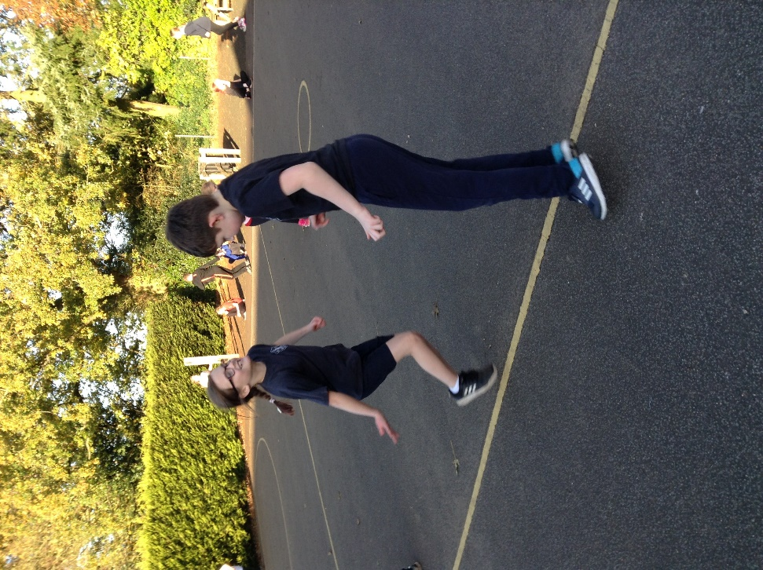

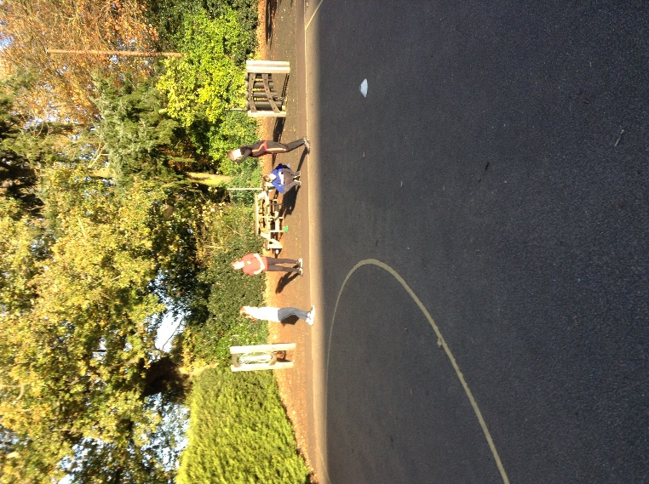

We organised ourselves into small groups to make it more of a competition amongst ourselves as well as the other schools and we used our Young Leaders skills to count each other’s scores and report back.


