Children in Need and World Kindness Day

During the week leading up to Children in Need Day (9th - 13th November), Class 4 took part in ‘Five to Thrive’. This included daily 5-minute physical activities and themed assemblies focussing on mental health and wellbeing. These were led by Joe Wicks, ‘The Body Coach’.
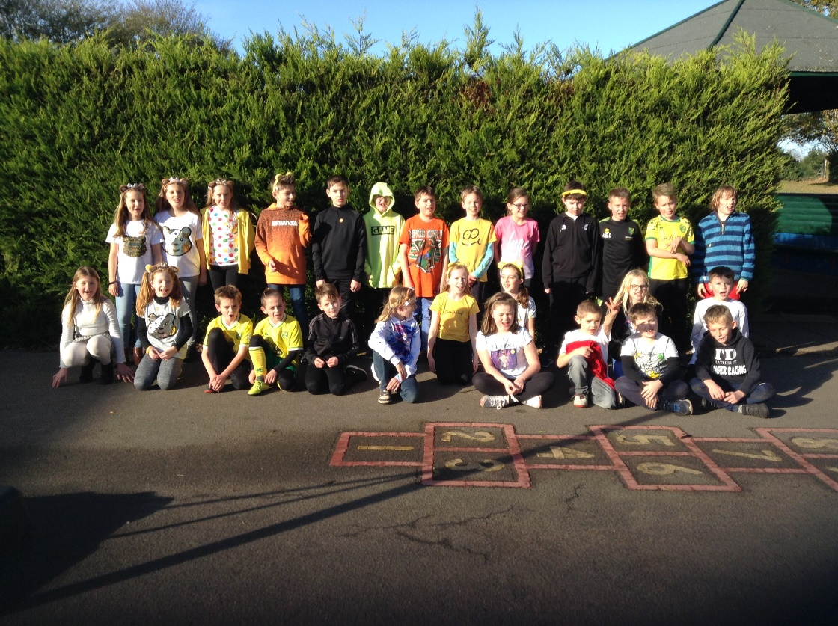

On Children in Need Day itself, we dressed in either bright or spotty clothes and made donations to the charity. We also bought biscuits from the school kitchen as a way of raising more funds.
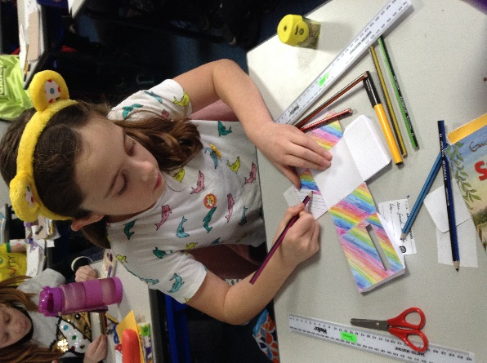
It was also World Kindness Day on Friday 13th November. We talked about the meaning of kindness and how kindness, including random acts of kindness, can improve people’s lives. We made special post boxes to keep safe little notes saying positive things about ourselves. Each member of the class paid a kind compliment to their partner to include in their post boxes.


