Remembrance Day
11th November 2020

The children in Class 2 have been learning about Remembrance Day and why people wear poppies.
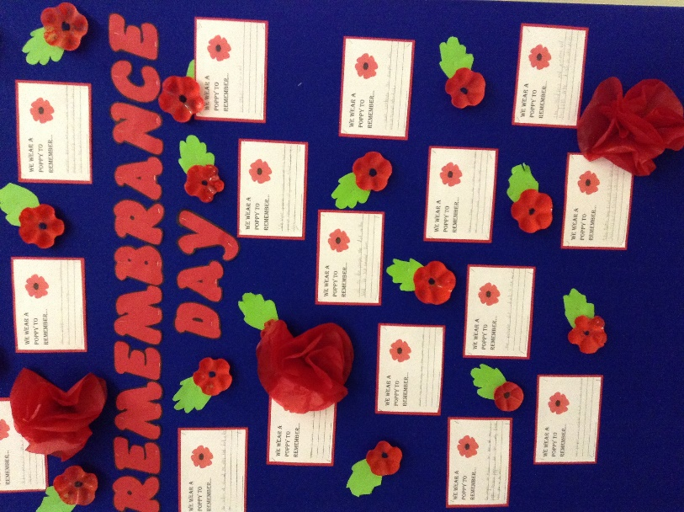

The children wrote about remembering the people who died in wars and we made a display. We recycled plastic bottles and painted them to represent the poppies.

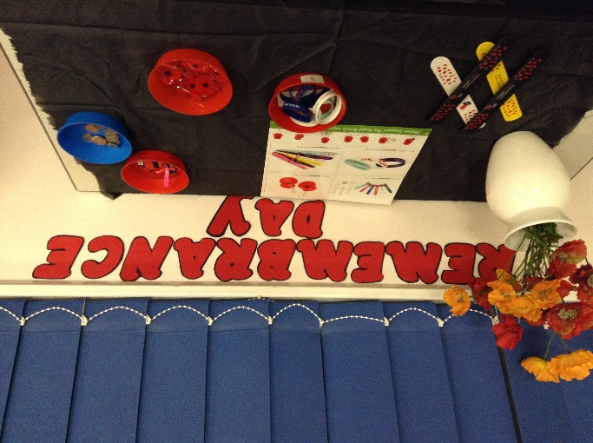
We made a display of the items on sale from the British Legion. The children brought money in and the School Council Representatives sold them. The slap bands were very popular.

