Christmas is coming…

It is a good sign that Christmas is on the way when we have our traditional Christmas ‘Decoration Day’ on the last Friday of November and today (27th November) was no exception.
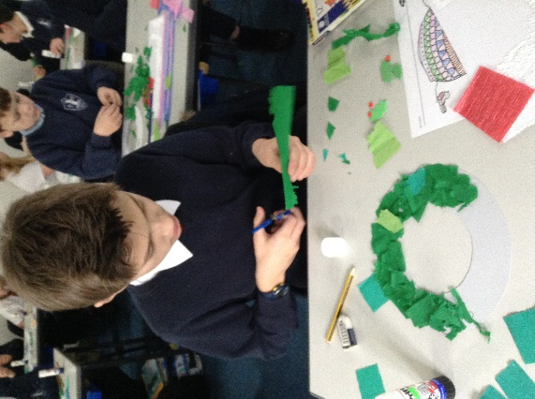
We enjoyed listening to Christmas music as we made a variety of decorations to brighten the classroom.
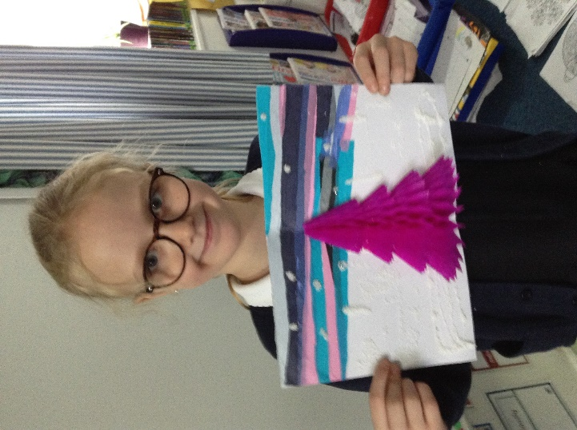
We made 3D sunset Christmas cards, wreaths and snowman garlands. Many of us also made our own choices of decorations for Miss De Vanche to have in the office.

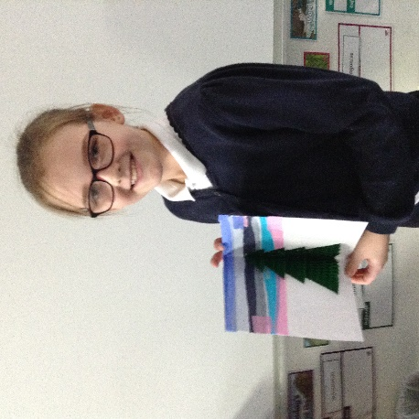

Thank you to Sam and Summer for decorating the class tree. The classroom now looks very festive.
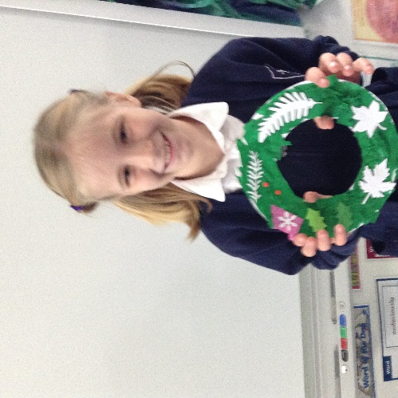
We are also extremely grateful to Mrs Mills for kindly donating many craft items for us to use and Miss Waters for organising today’s activities. It has been a memorable day. Let the festivities begin…


