Christmas Post-box

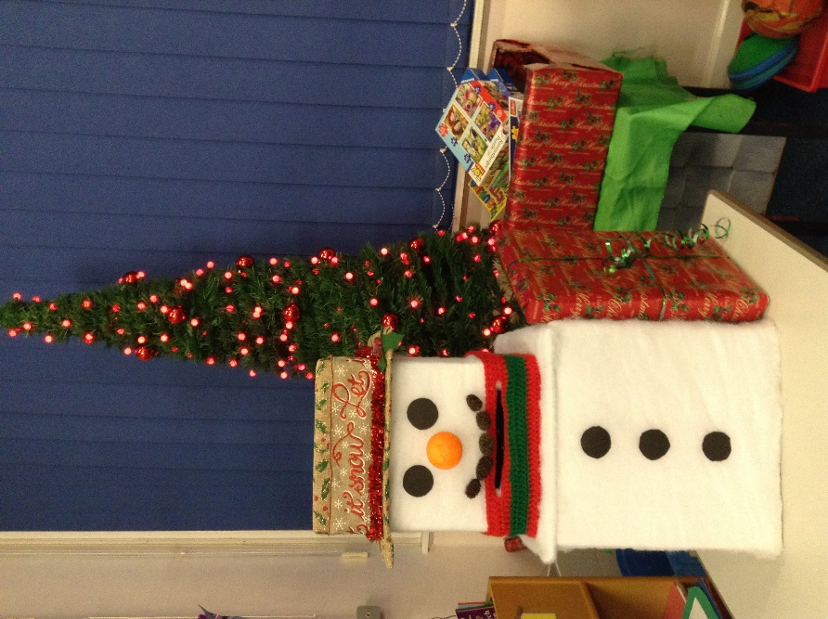
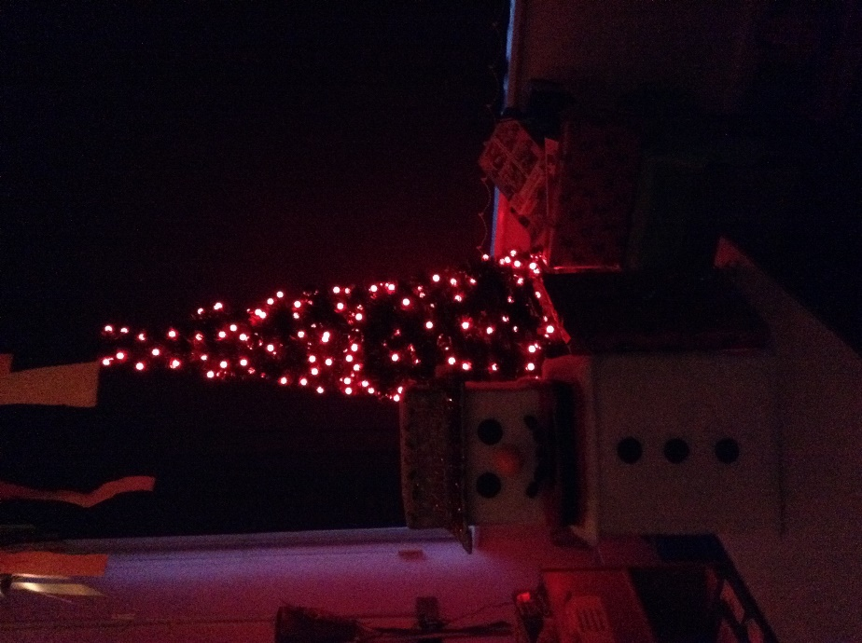
Unfortunately this year, the children are unable to put their cards for the whole school in our usual post-box. Class 2 asked one of the parents if they would be able to create a post-box just for us. I supplied the parent with a small box and an assortment of Christmas themed craft items. We were all so surprised when our snowman arrived!
He is so wonderful that we have decided to have a competition on party day to give him a name. Will he be Icedrop or Snowdust or Chilly? The children have decided on 18 names and one of them will be chosen as the winner. The winner will be given a prize, which was donated by another Class 2 parent, at the party. I would like to take this opportunity to thank you all for your support over the last term. It has been a bit challenging at times, but the children have been stars and I am so proud of them. We have had four weeks with no absences!

