A Surprise or Two
A surprise or two sums up this week in Class 4. The first surprise was a recorded message from our French pen pals. They emailed photos of themselves reading our latest letters and clips of themselves thanking us for them. We responded by filming a clip saying thank you and wishing them ‘Merry Christmas and a Happy New Year’.
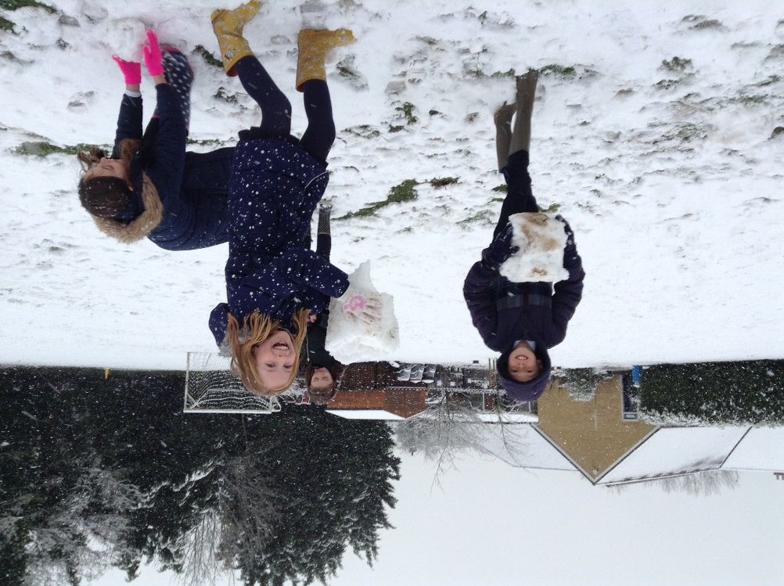

The second surprise came at the end of the week: SNOW! It has been nearly two years since the last snow fell here so we were very excited!


