Rainbow Superheroes Day
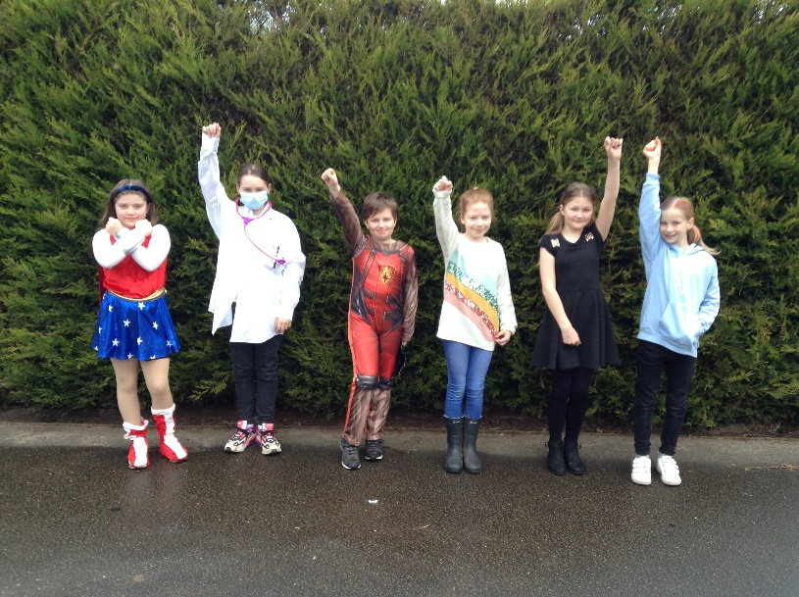
On Thursday 25th February, we joined with other schools across Norfolk to celebrate and show our appreciation of all of the key workers throughout the pandemic. Children in school and learning remotely took part.
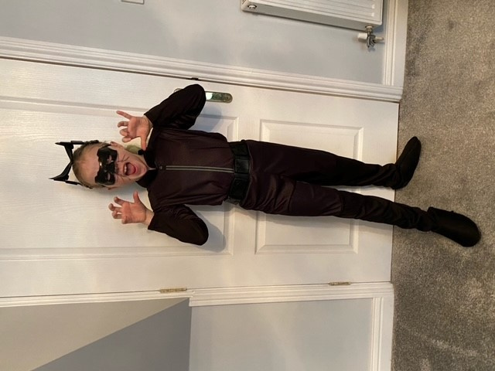
We dressed as superheroes, we gave our thanks through poetry and did art-based activities including designing a new uniform for a critical worker with a rainbow theme, making rainbow superhero masks, and making bunting.

