World Book Day 2021

On 4th March children at school and learning remotely took part in the annual World Day celebrations.
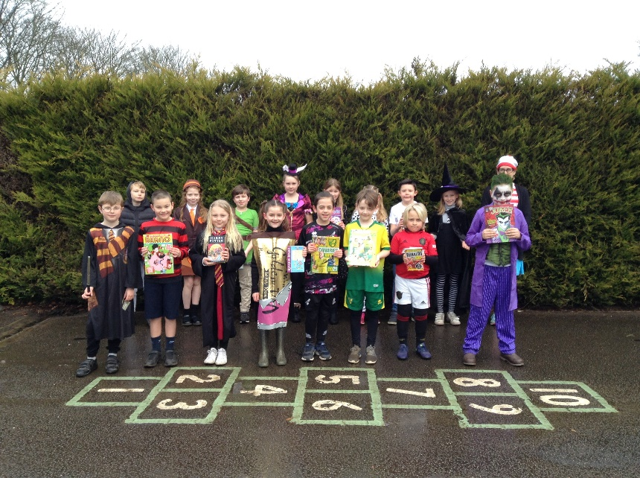
Children and staff dressed as book characters and took part in a range of book-based activities including a live quiz on Teams.


