HISTORY

Our history topic for the first half of the spring term was: Toys from Long ago. We usually organise a trip to Ely Museum for this topic, but unfortunately due to coronavirus, the museum was forced to close.
We managed to book an online session through Teams while the children were at home and engaging in remote learning. All pupils in KS1 were invited to join in to the session. Although we encountered some technical issues, they were able to watch, and listen to knowledgeable staff members from the museum who were able to answer their questions.
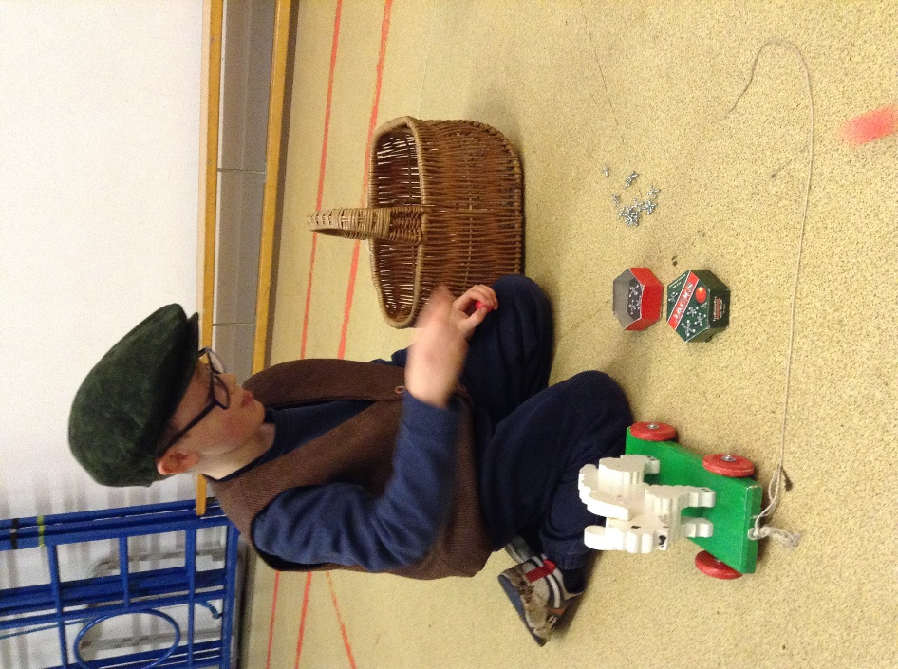
On their return, they were able to handle the resources that had been left in school for the children. The children in Class 2 had a fabulous time discovering the toys and asking lots of questions. It was a successful alternative to our normal event.



