Class 4 news
What a busy week it has been with a full return to class to all of our children! With 100% attendance on the first morning back, it was a fantastic start. It has been a delight to have everyone together again.
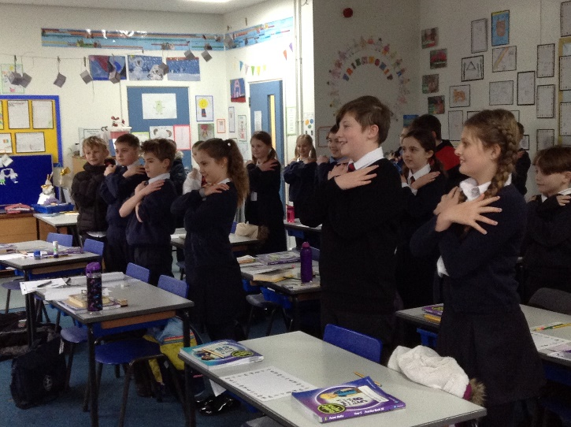
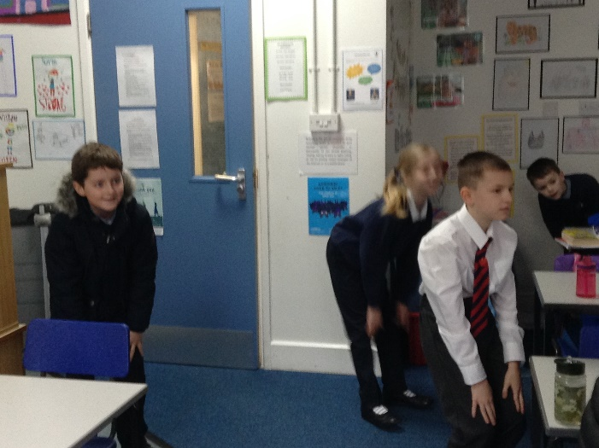

On Monday we enjoyed being able to reunite with our friends. We had a special active assembly ‘EFL - The Joy of Movement’ focussing on wellbeing which was organised by Norwich City Community Sports Foundation and delivered live via Teams. We also had an interactive practical science lesson exploring the effect of increased voltage in circuits. More experiments will follow on Monday.
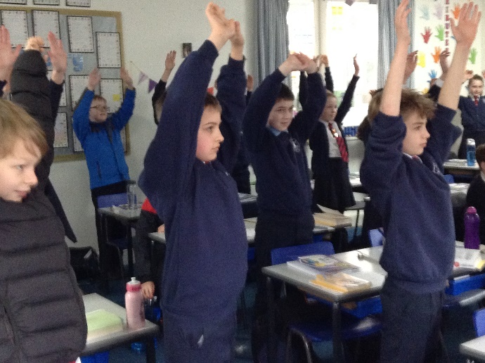
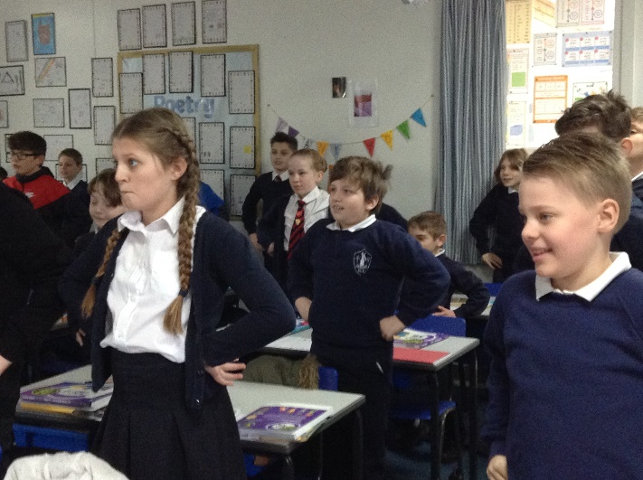
Tuesday was glorious so we made the most of our PE lesson outdoors with team Scatterball and Golden Mile relays. We also had an enhanced RSHE lesson. We explored how to be safe near railways as well as considering the specific dangers of electrification of railways with resources from Network Rail. We were also joined again live for another interactive session organised by the NCCSF team to explore the theme ‘Diversity – no room for racism’.
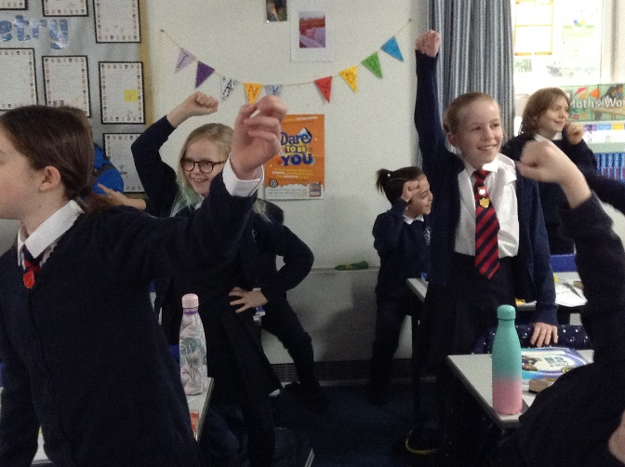

On Wednesday, we made great strides in our preparations for Bishop Stephen’s Lent Challenge. The theme this year is ‘Hope’. Mr Lawrence introduced us to songs of hope, one of which we are going to record as part of the challenge. Mr Sexton also taught us of the importance about being discerning over digital content online and to be aware of ‘fake news’.
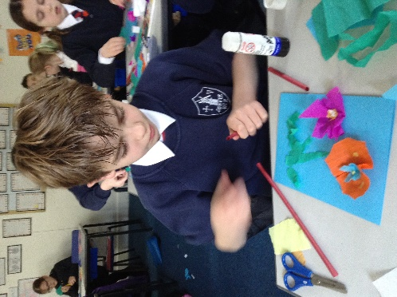
During Thursday’s RE lesson, we continued to develop our contributions towards Bishop Stephen’s Lent Challenge by writing prayers of our hopes for the future and creating word art clouds of the same theme.
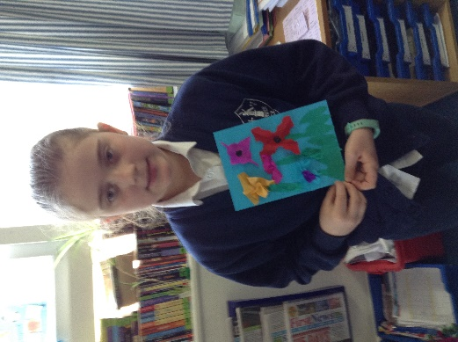
And lastly, Friday. The Ladies of Denver Church community generously donated a range of foliage for us to make Mother’s Day posies. We also made cards for the occasion. In the afternoon, we finally were able to watch the pantomime ‘The Wizard of Oz’ which we had originally planned to see in mid-December. We watched from the safety and comfort of our own classroom with popcorn, ice-cream and cakes delivered by Miss Palmer and Miss Fenn from the school kitchen. Mrs Jones gave us a surprise soaking with a giant water pistol in the interval!
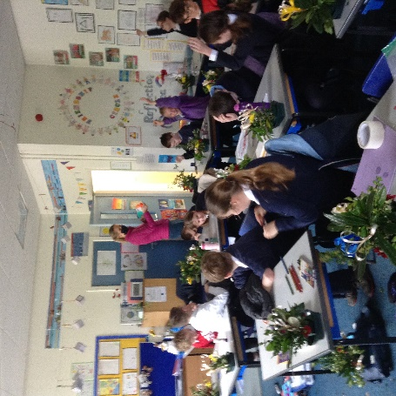
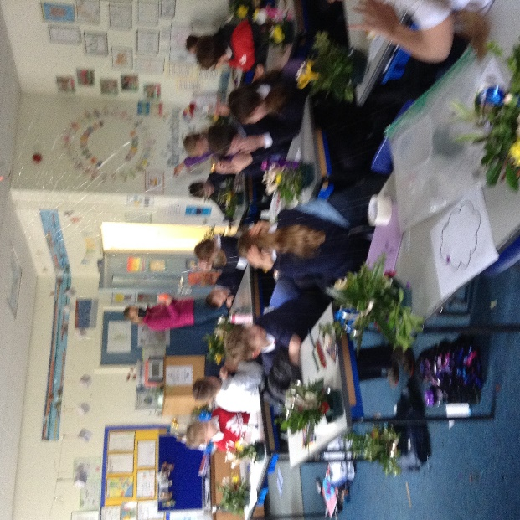

Thank you to everyone who has contributed to making sure that the children’s return to school has been positive and memorable.
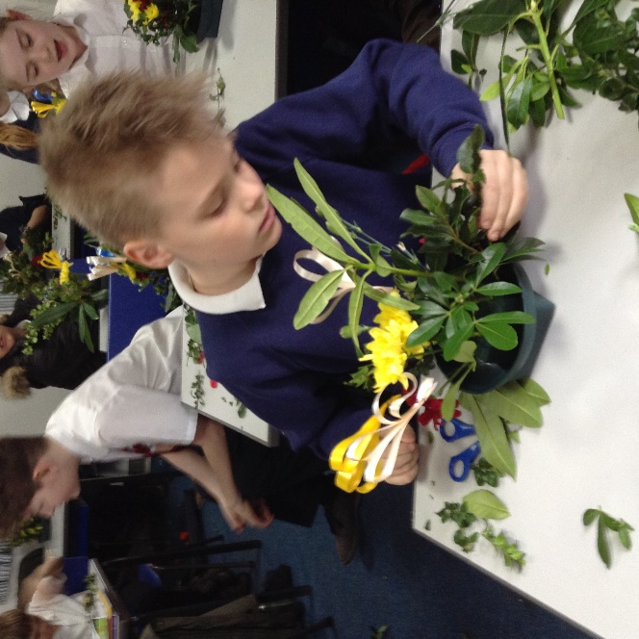

Here are some more photographs of this week:
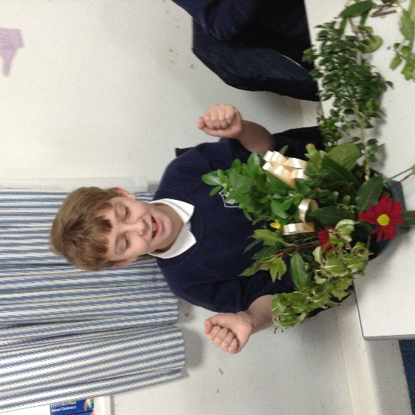

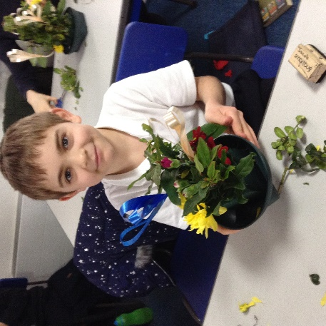
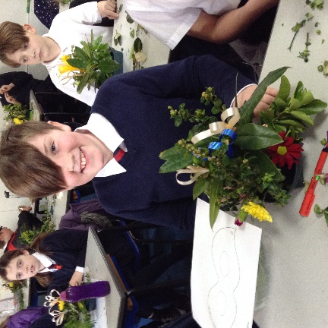
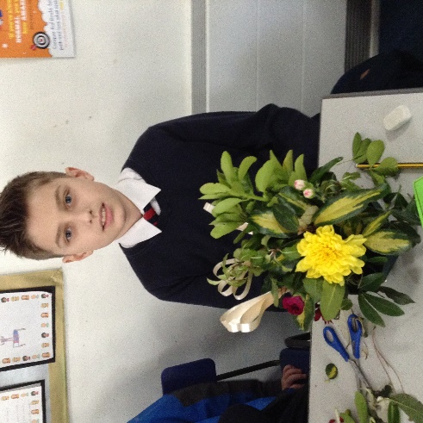
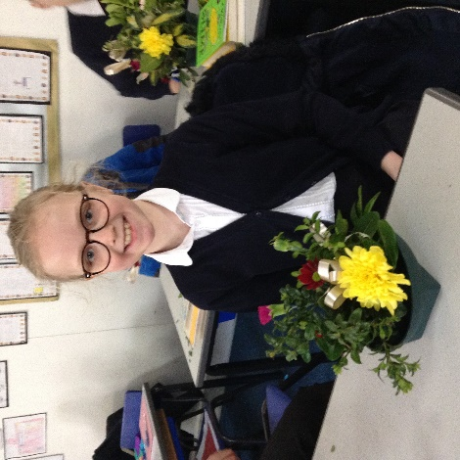
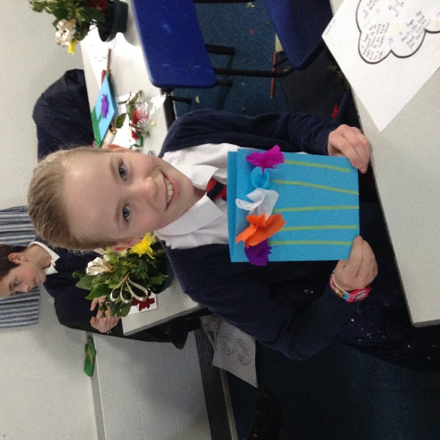
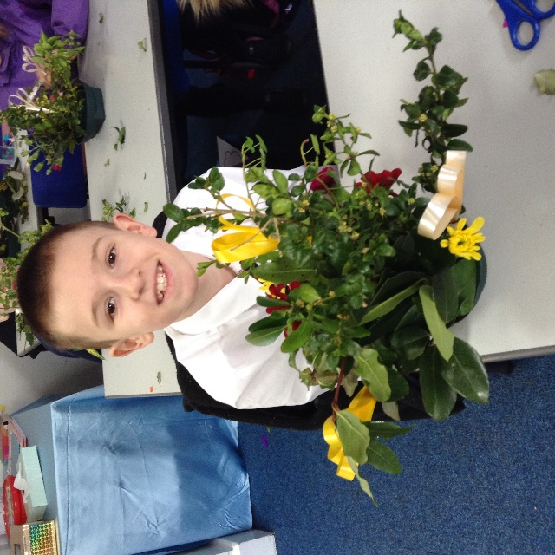
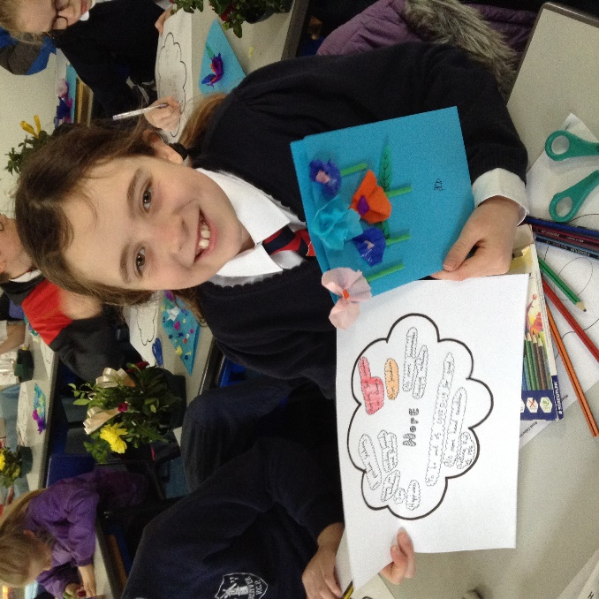
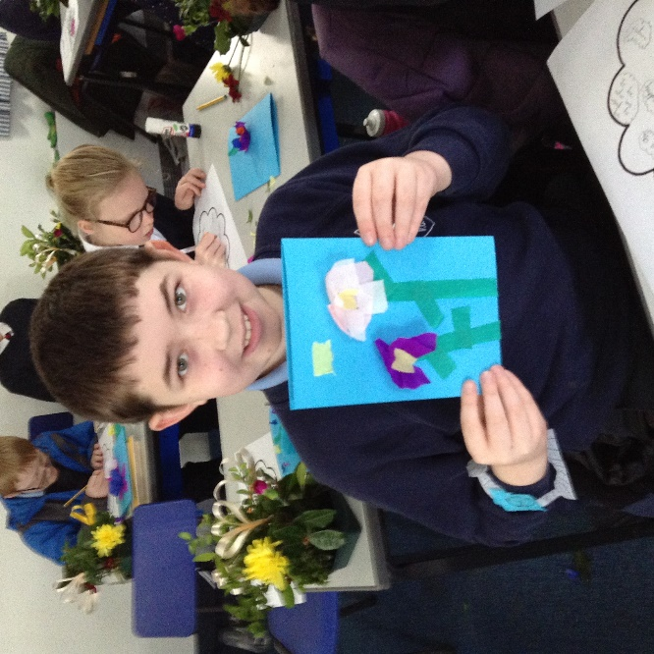
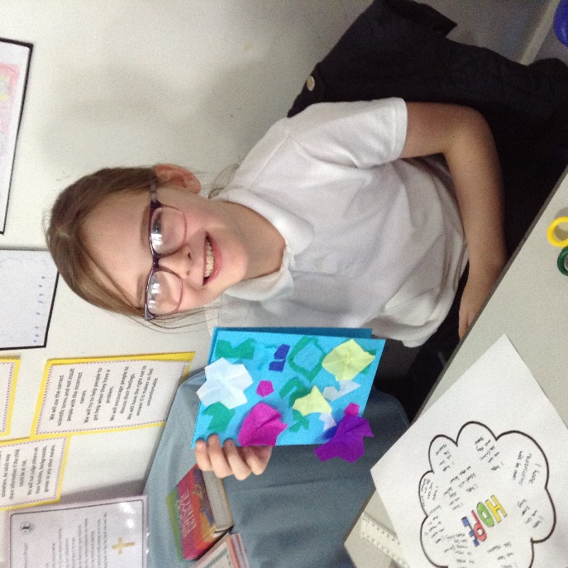
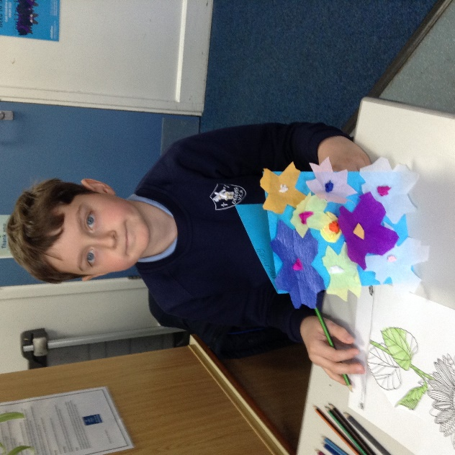
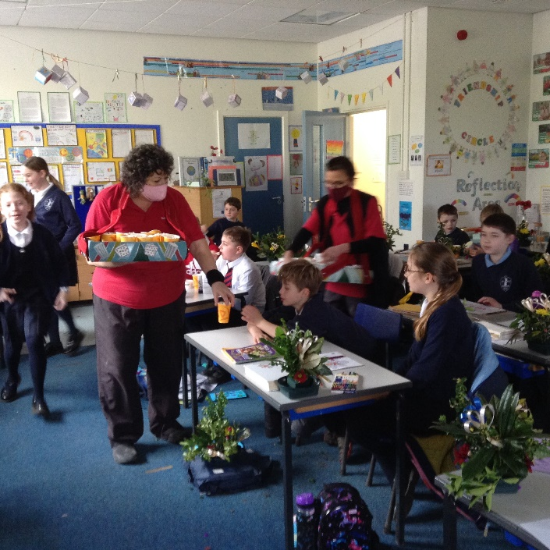
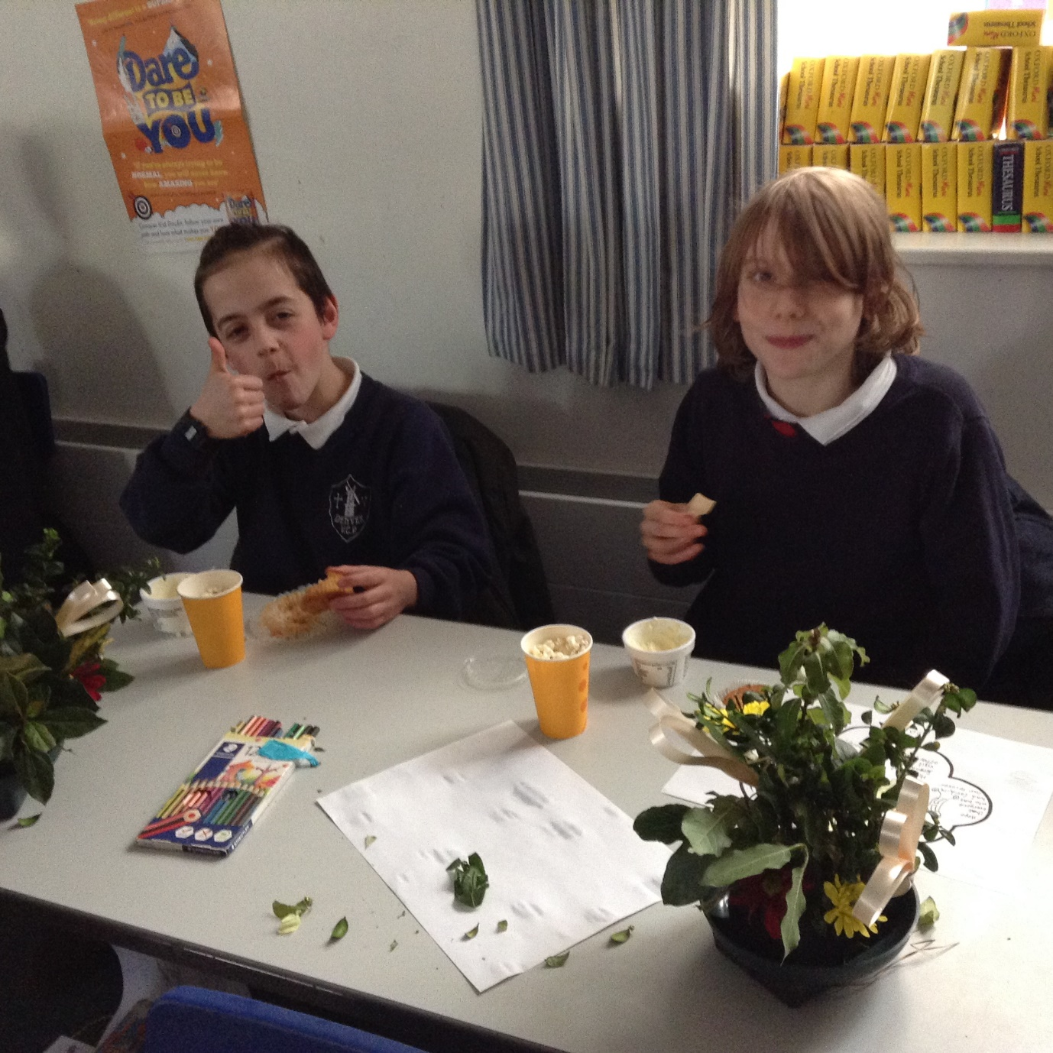

12th March 2021

