Bikeability training for Year 5 children, May 2021
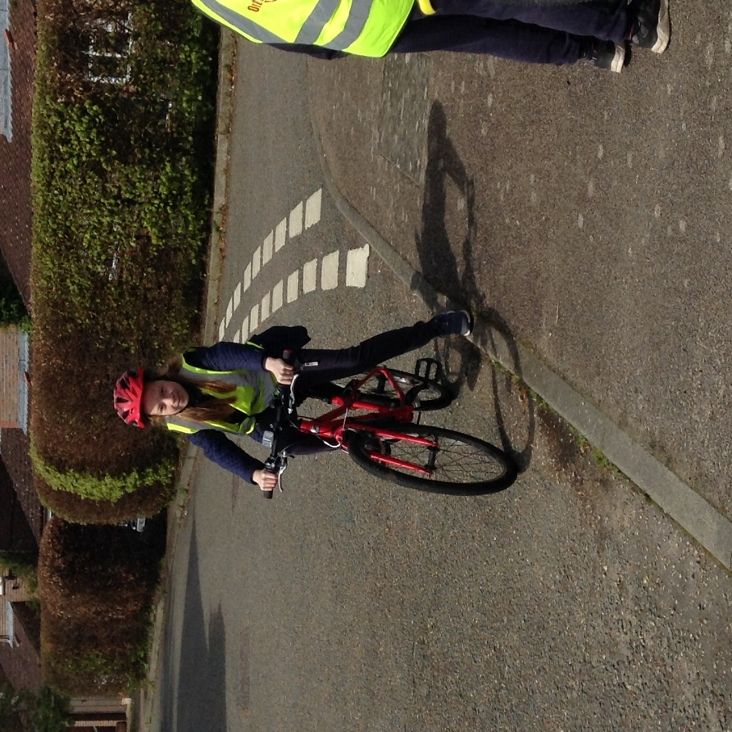
This week the children in Year 5 took part in four days of intensive cycle training, ‘Bikeability,’ organised by Outspoken Training to enhance our both their PE skills and RSHE safety curricula.
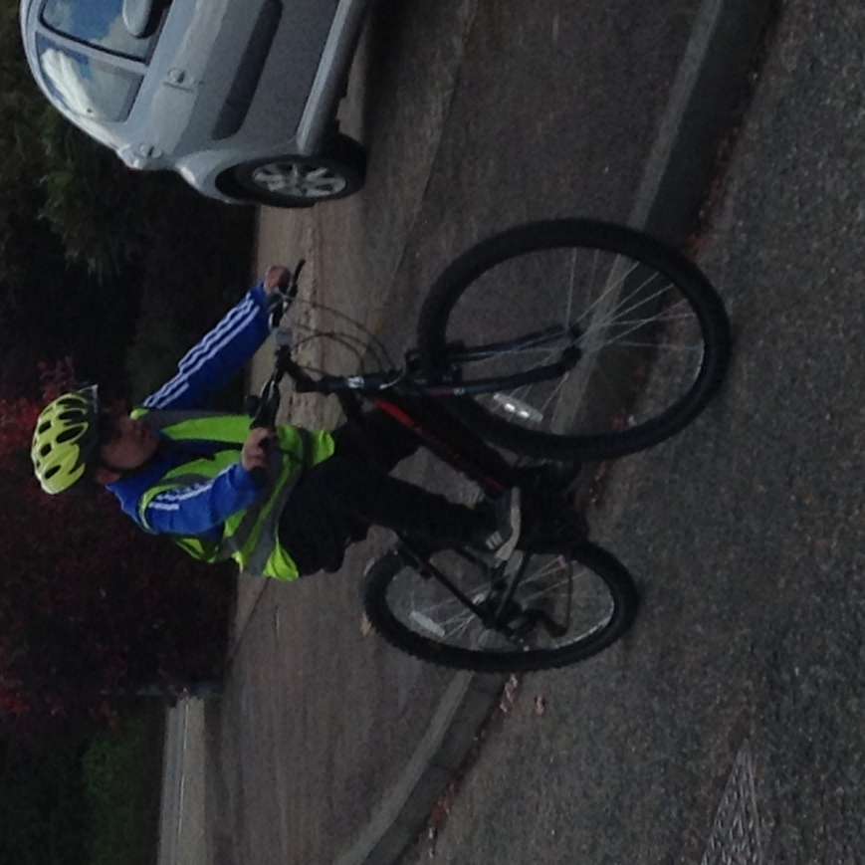
Day 1 involved onsite training. The children learnt how to inspect and adjust their bikes and to perform manoeuvres in the safety and familiarity of the school grounds. Completion of day 1 training resulted in the achievement of the Bikeability Level 1 award.

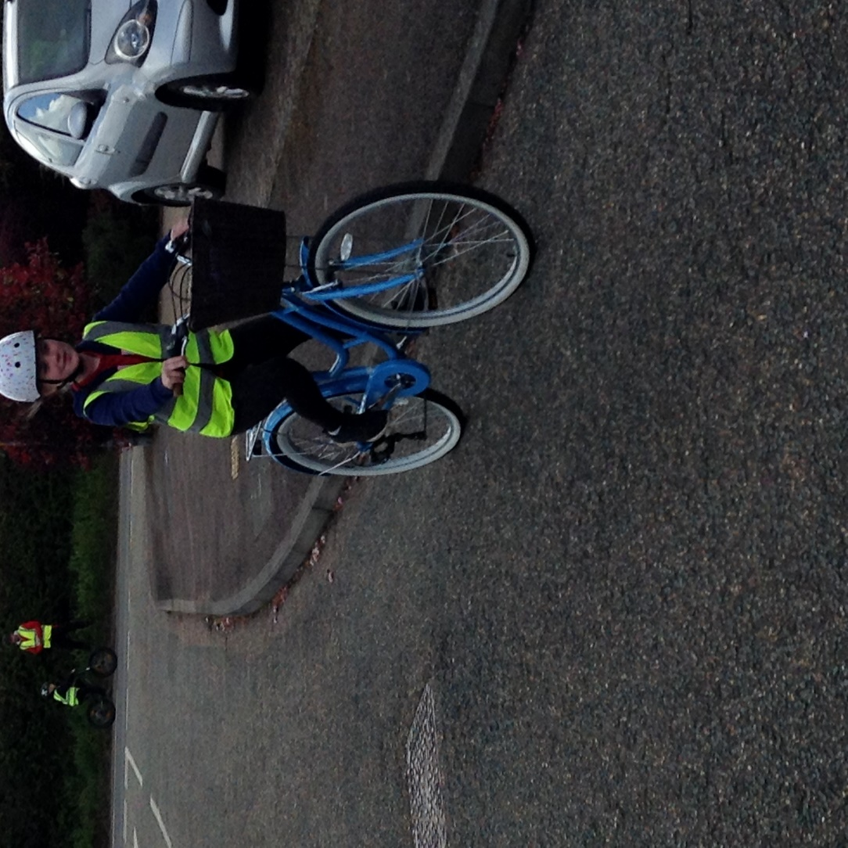

Once this was successfully completed, the children then progressed to the local roads with the two instructors and Miss Waters. They were able to put into practice the skills taught on day one with real life hazards such as pedestrians and traffic (and, of course, the inclement weather!). They also learnt aspects of the Highway Code. The completion of these three days of additional training has earned the children the Bikeability Level 2 award.

It has been a delight to hear of the children’s successes. Some of the children were very nervous at the start of the week but have tackled the challenges and made positive progress in self-belief as well as cycling competence.
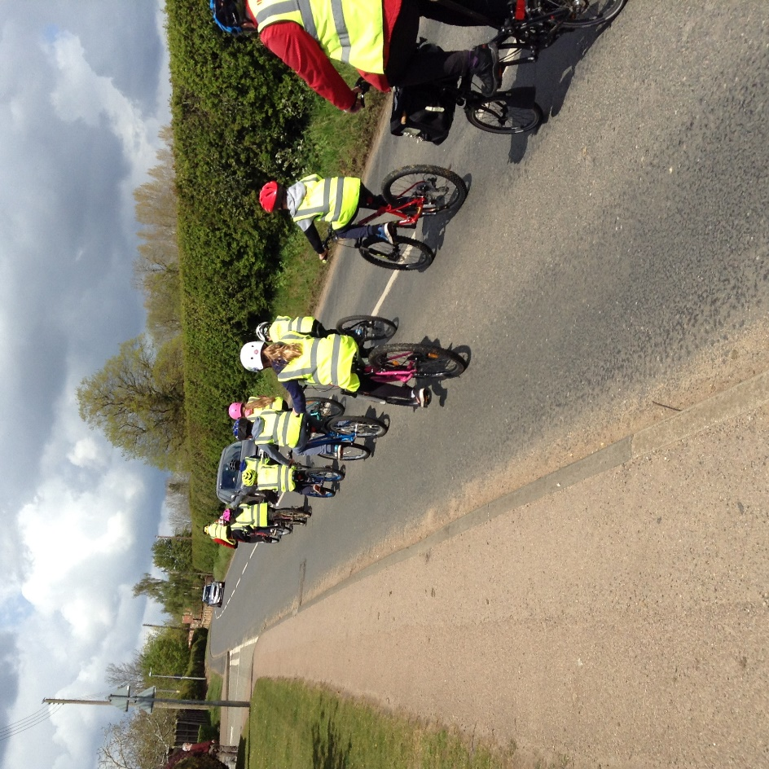

We are immensely proud of the children who were an absolute credit to the school and it has been lovely to end the week with another proud class teacher moment. Kevin and Rob, the instructors, remarked on numerous occasions how much they have enjoyed working with our Year 5 children. They referred to them as enthusiastic, skilled, delightfully polite, respectful, very well-behaved and sensible. As they left today, they were feeding back to Mrs Jones about how much they have enjoyed their 4 days here at Denver, in particular, about what a warm, welcoming and friendly school we have been.


