Downham Market Academy CSI themed taster day (25.06.21)
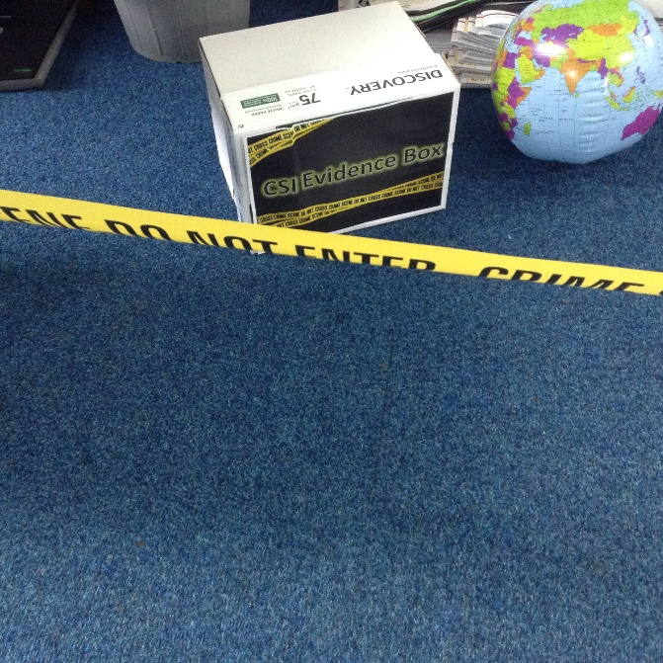
At this time of year, Downham Market Academy usually invites the Year 5 children of feeder schools for a themed event to attract them to apply to the school as their preference for secondary school. They would also normally be inviting Year 6 children to their transition days.
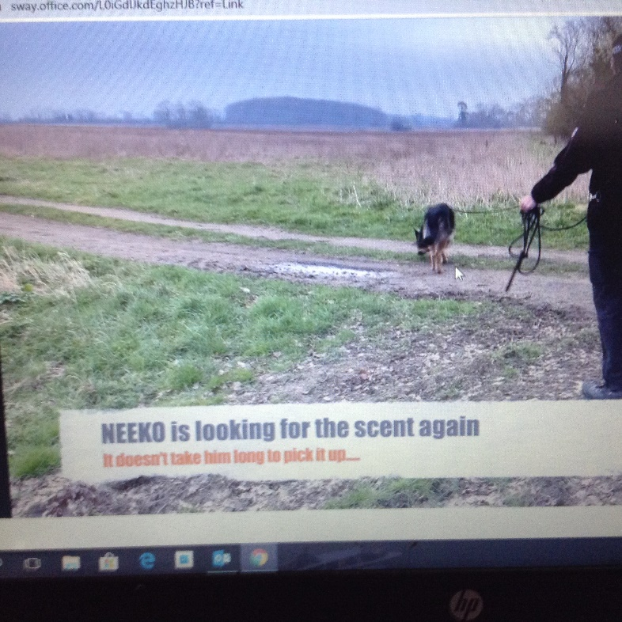
Unfortunately, due to the current restrictions, they are unable to welcome the children to the site so they have instead sent resources to the feeder schools to deliver within our classrooms. The resources have allowed the children to become familiar (via video clips) with some of the staff and the buildings.

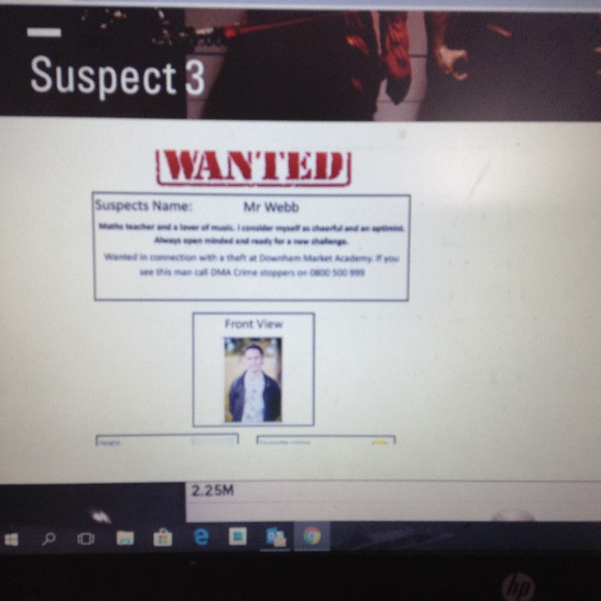
This year, the theme was Crime Scene Investigation. The children worked through different reading, science, maths and writing tasks to solve the mystery of who stole the calculators from the maths classroom. The activities included finger printing and chromatography.
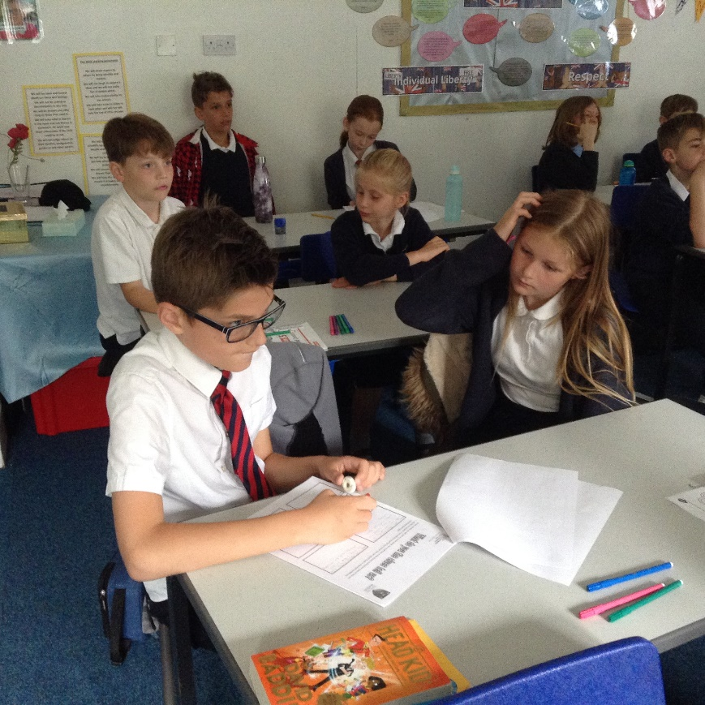

We had a great time – the mystery kept us guessing right to the end!


