Young Leaders Session 2
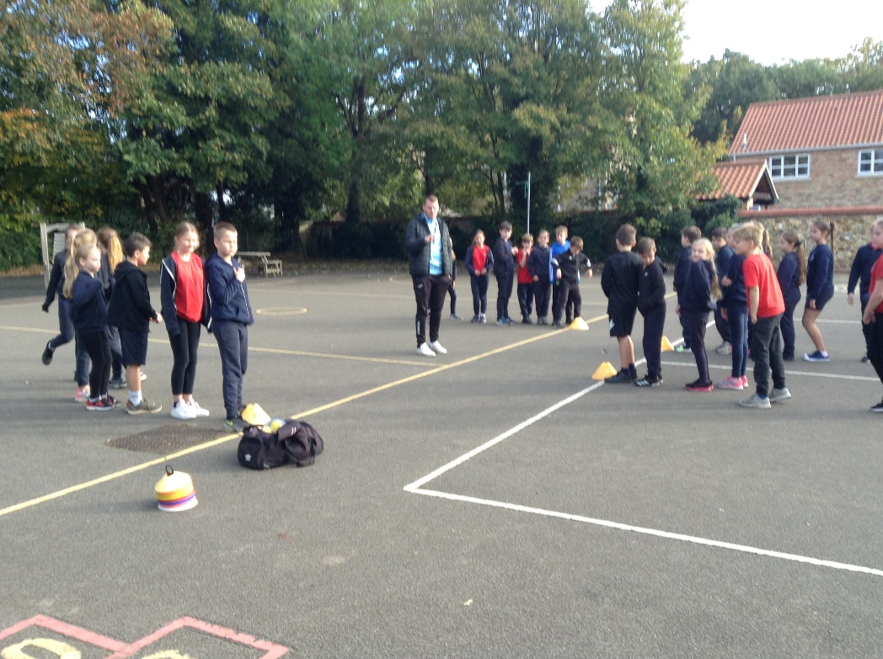
On Tuesday (9th November) Joe from KLCF returned for the second Young Leaders session.
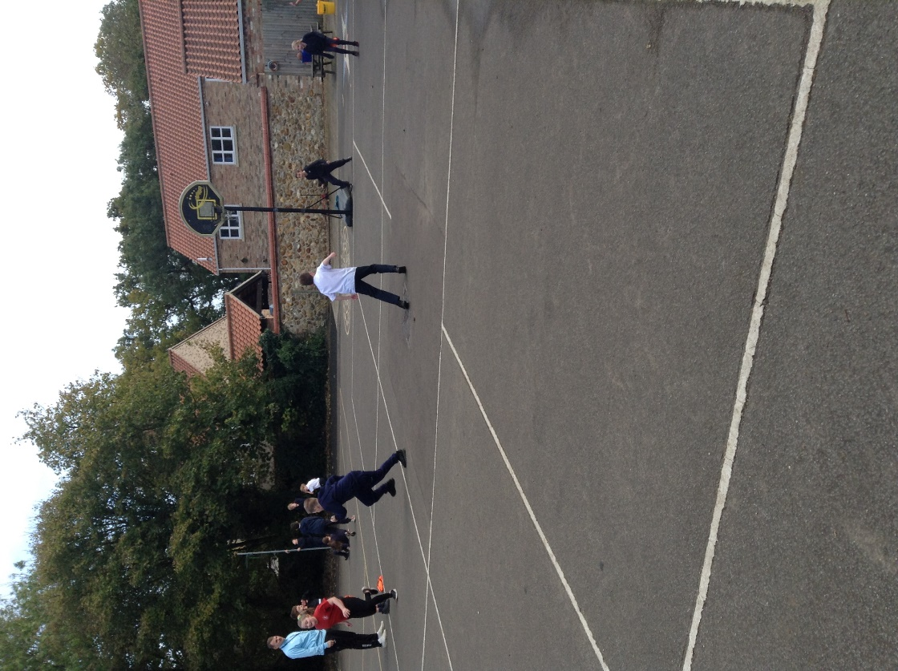
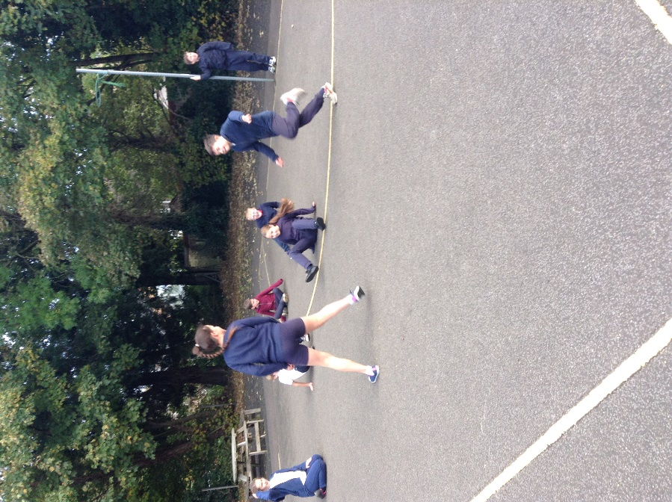
This time there were two main learning objectives. The first was to be able to select and use an appropriate area for an activity. This included assessing health and safety, the type of surface and the size of the area in relation to the numbers involved and how it facilitates the intended game or activity.
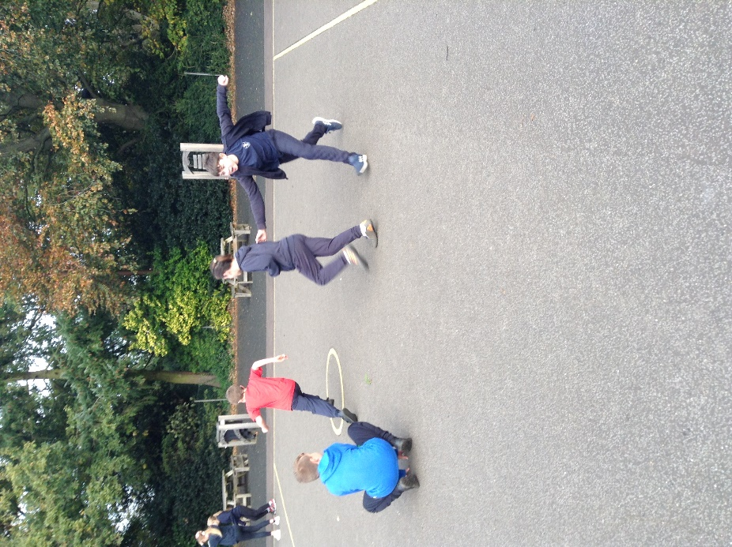

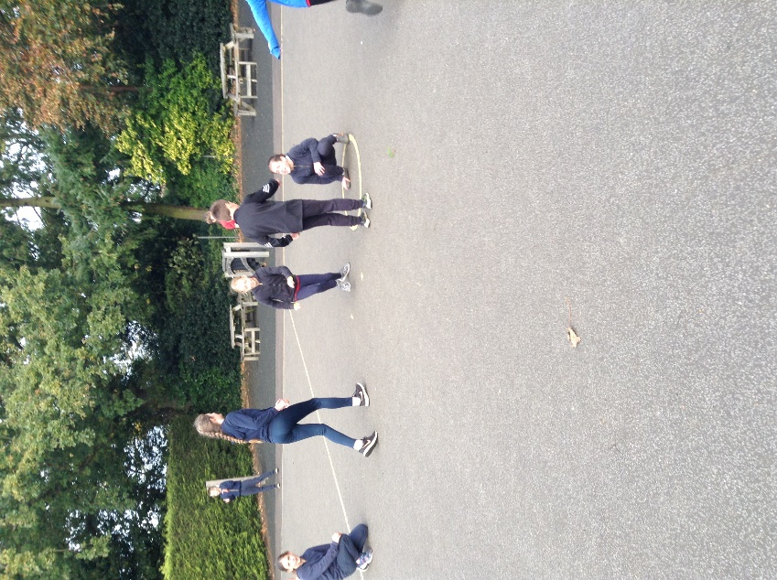
The second was to be able to communicate effectively as a leader. This involved being able to project our voices to be heard, to start, stop and change games, to clarify rules and how to step in where there are any issues or accidents.
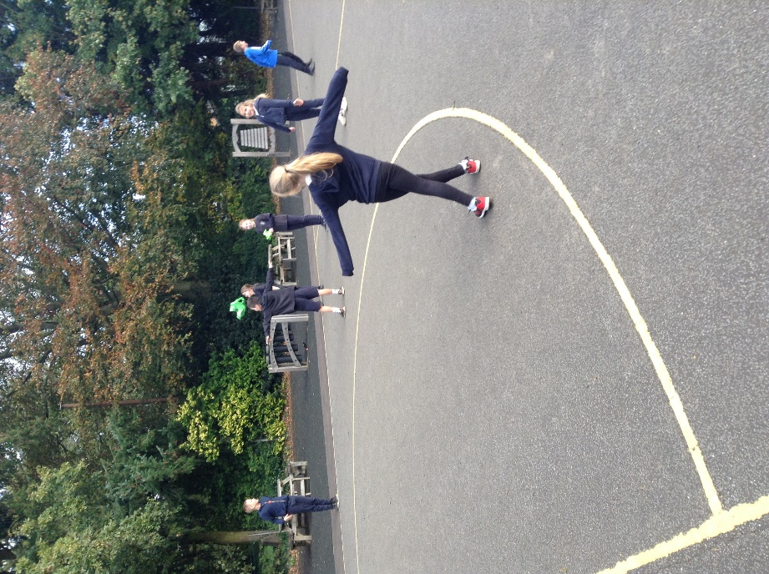

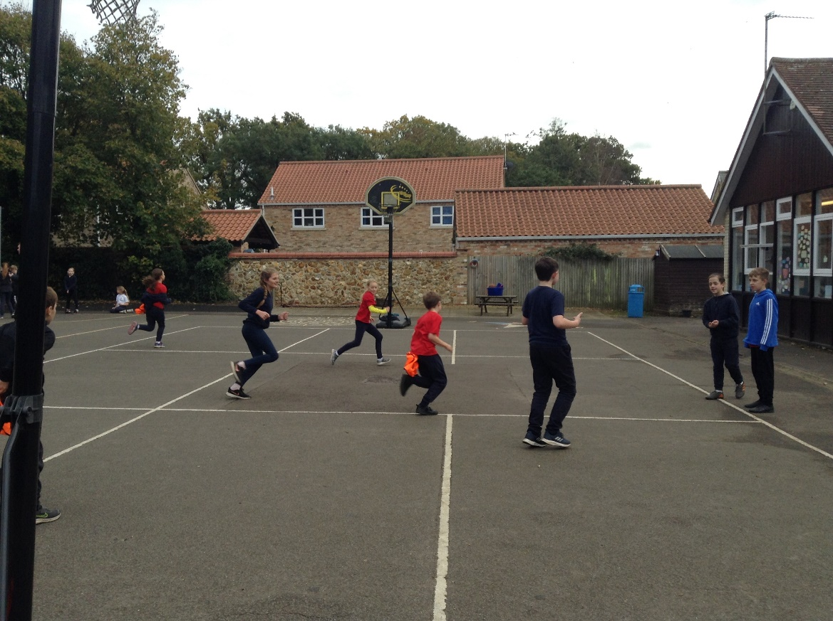
These skills were practised in a range of tag games: Chaos Tag, Socks, Sharks and Swimmers and Stuck in the Mud. It was a very energetic session which definitely had everyone being active.
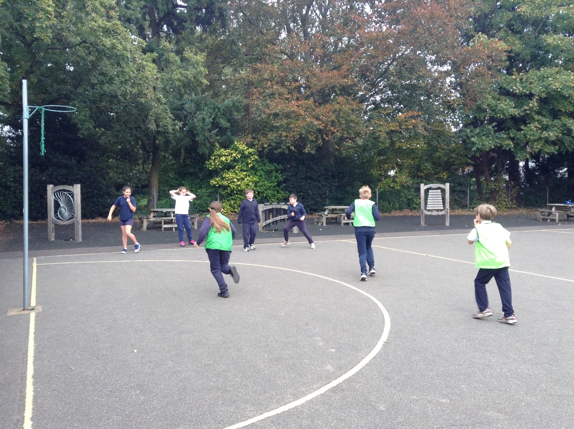

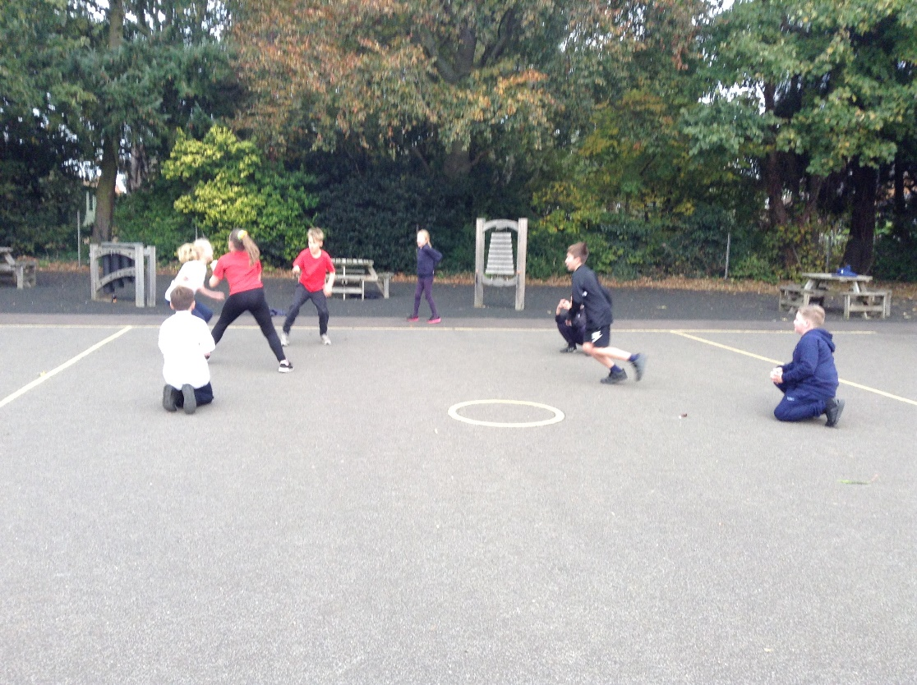

The third and final session will be next Tuesday where the children will learn about organising and selecting suitable equipment for leading a range of games.



