Active Kids
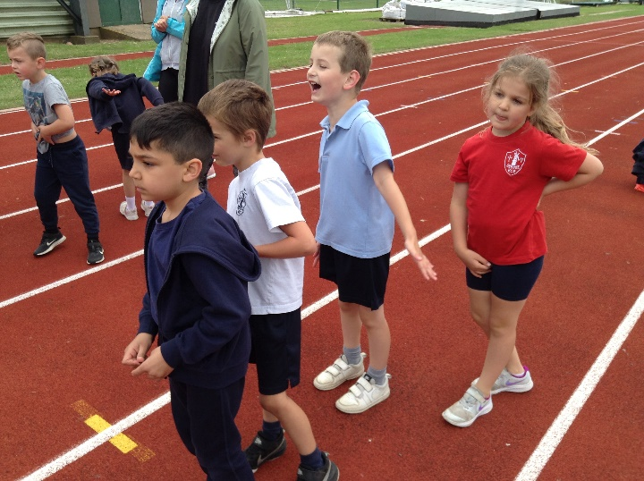
On Monday 19th October 2021 Year 1 pupils had a P.E. event at Lynnsport in King’s Lynn. It was a very exciting day for them as it is the first time they have been on a school trip. For some of them, it was the first time they had even been on a coach!
There were nine other schools taking part and it was a great opportunity to meet children from different schools and compete against them.
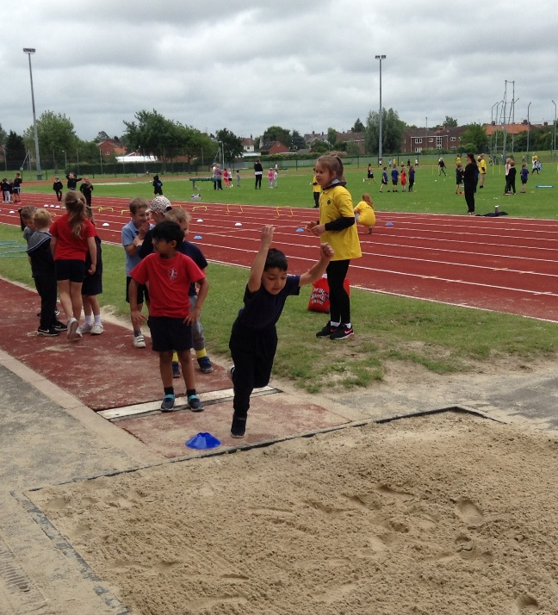
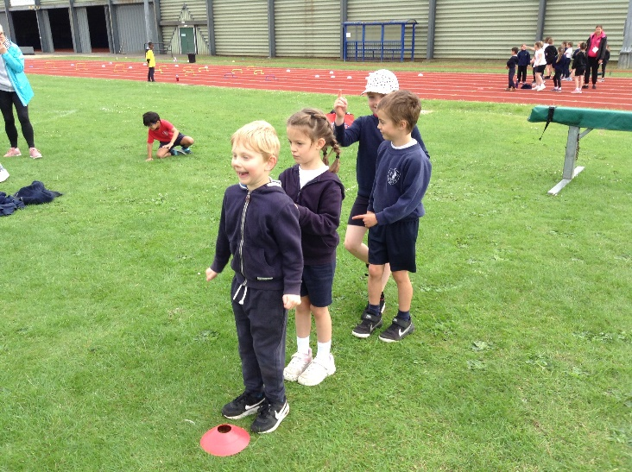
The activities involved practising and perfecting their throwing and kicking skills. A carousel was organised and the children were kept very busy throwing and catching bean bags. They threw them at dinosaurs and skittles and kicked the football at the coconut shy. These were just a few of the games they played.
The children were all very well behaved and enjoyed their first school trip. They showed lots of team spirit and were encouraging of their team members.

