Class 4 visit to the National Space Centre
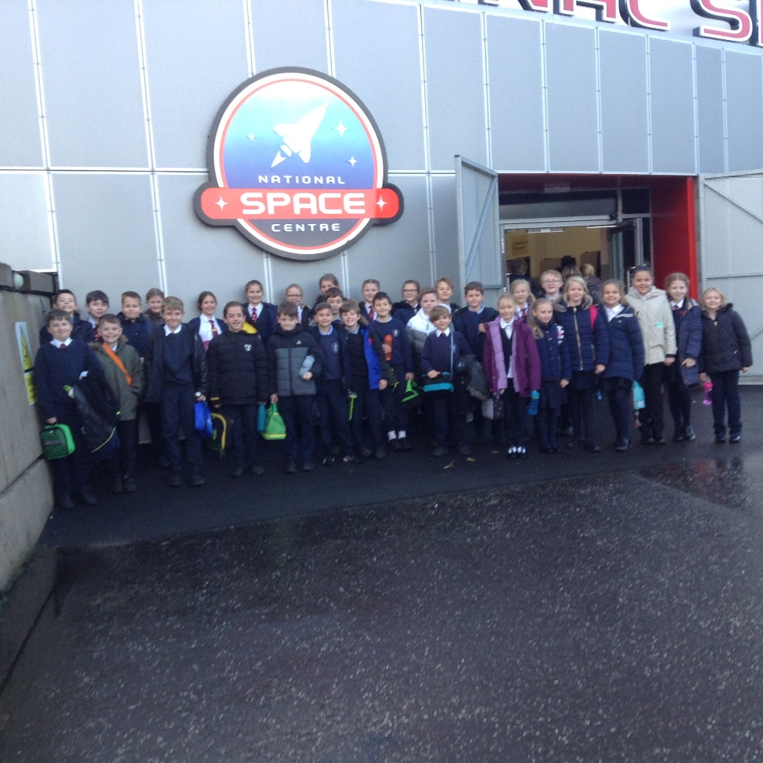
On Friday 26th November, Class 4 children visited the National Space Centre in Leicester to further their learning in science for the Earth and Space topic.
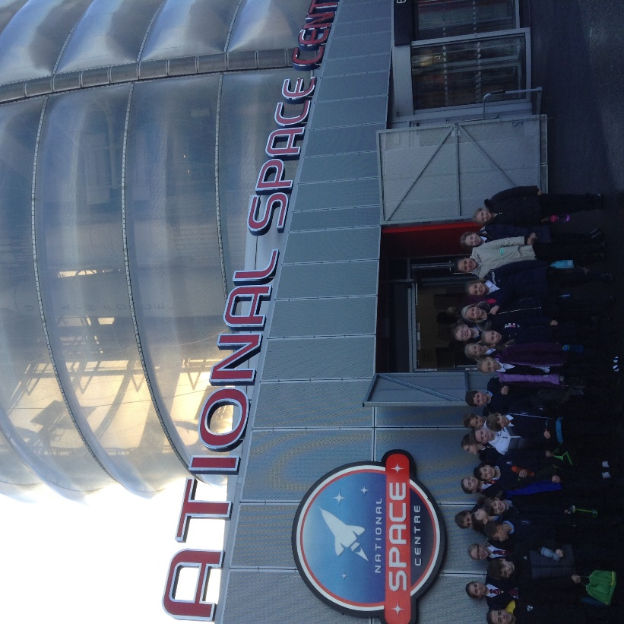
The journey was long but worthwhile. On arrival, they divided into two groups and spent time exploring the interactive galleries. On the ground floor were exhibits relating to space exploration, the birth of the universe, the Sun, Earth’s moon and the planets, and scientific research. A real hit was the ‘Weather Pod’ where the children were able to broadcast weather forecasts. This provided much amusement.
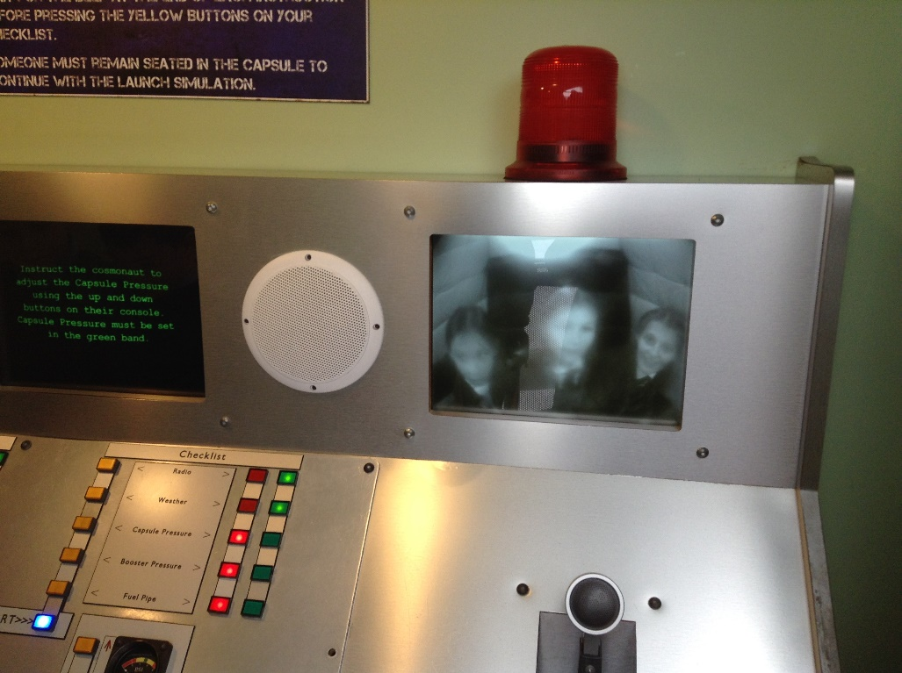
The other main gallery was Rocket Tower spread over 4 levels and separated with 54 steps between each of them – not everyone was a fan of the height. This gallery was all about how space travel developed over time and the intense rivalry between the Soviet Union and the USA to achieve the first major milestones in space travel and innovation: first to reach space, first animals in space (poor Laika the dog), first people in space and the first to land on the moon. This was demonstrated alongside timelines of other significant world sporting and political events, fashions, trends and innovations happening simultaneously to give an indication of where in history these events placed.
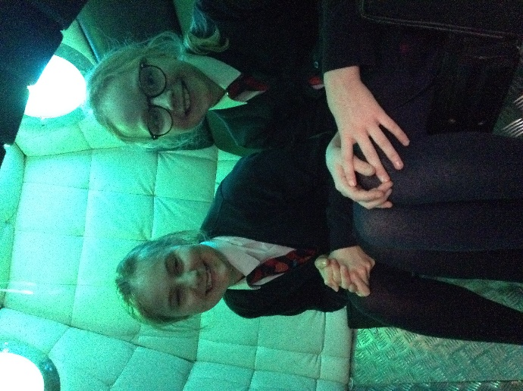
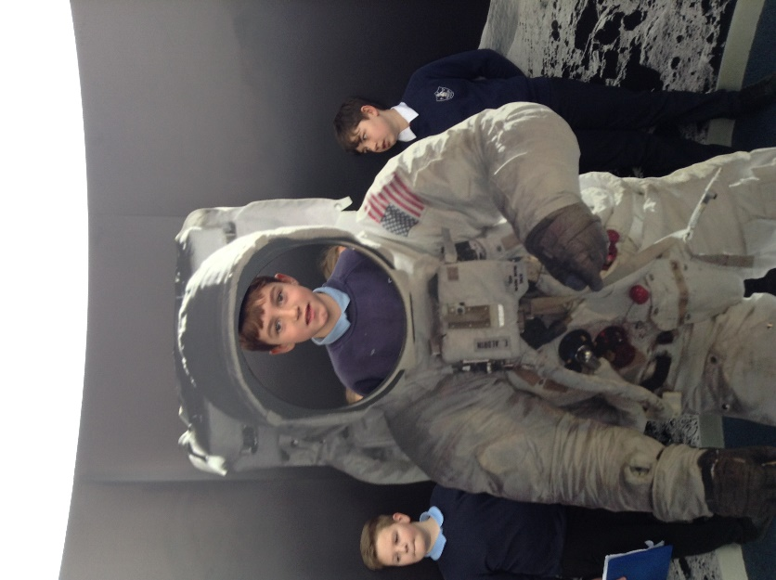
The highlight of the day was the Planetarium. In a large 3D cinema, Class 4 children watched a film called ‘Astronaut.’ The effects were very powerful – the children genuinely felt as though they were moving through space. They also experienced the feelings of astronaut training (centrifugal forces and weightlessness). They learnt of the dangers of space exploration and travel by watching a cartoon astronaut who suffered many mishaps.
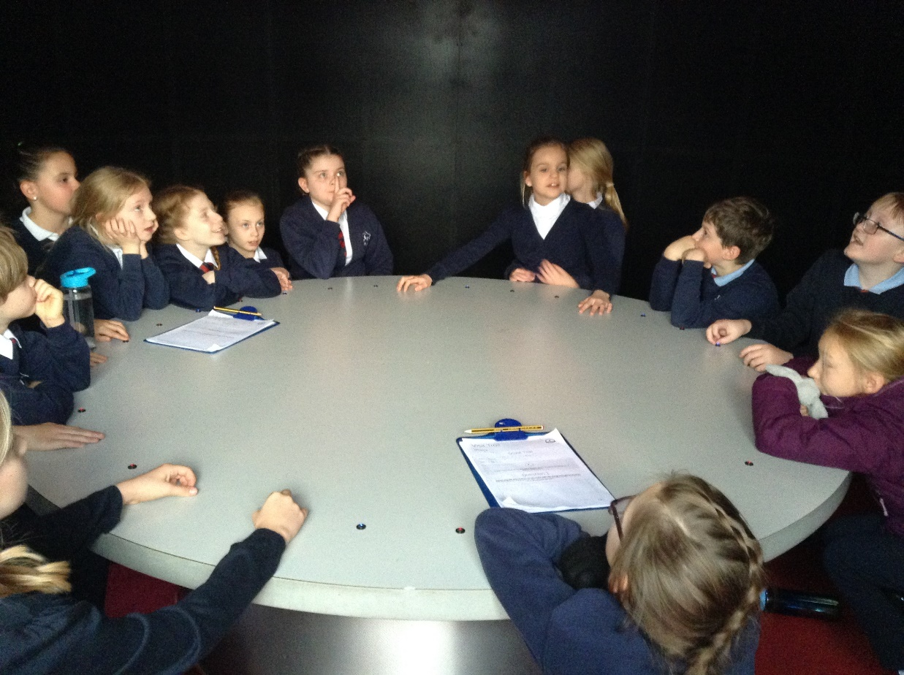

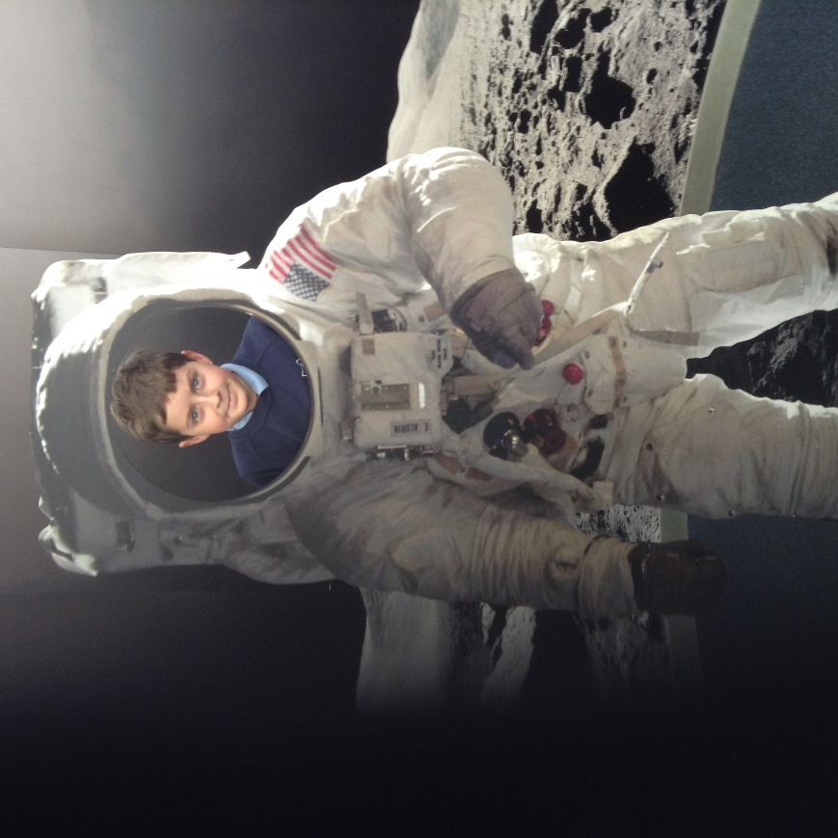
It was a very memorable day and such a delight to finally get out on a full class school visit since the beginning of the pandemic.

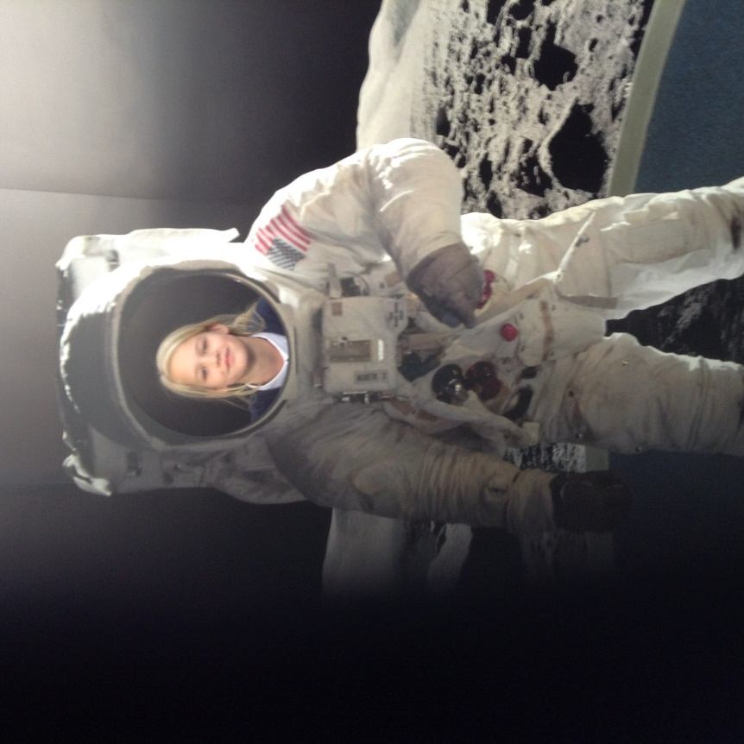

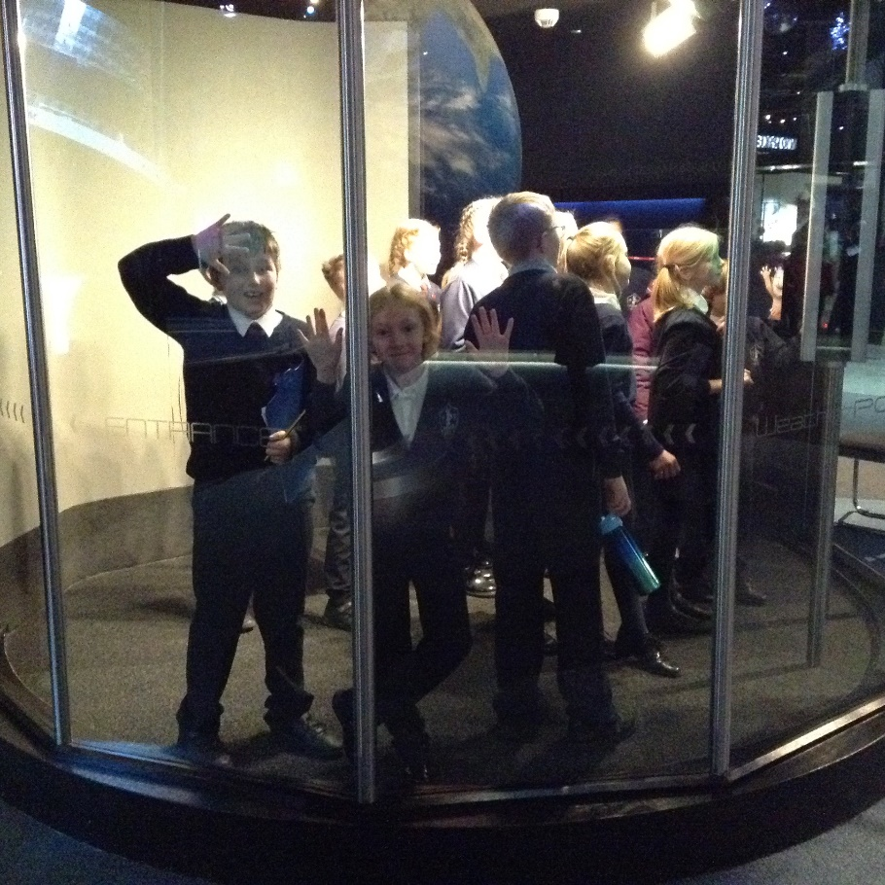
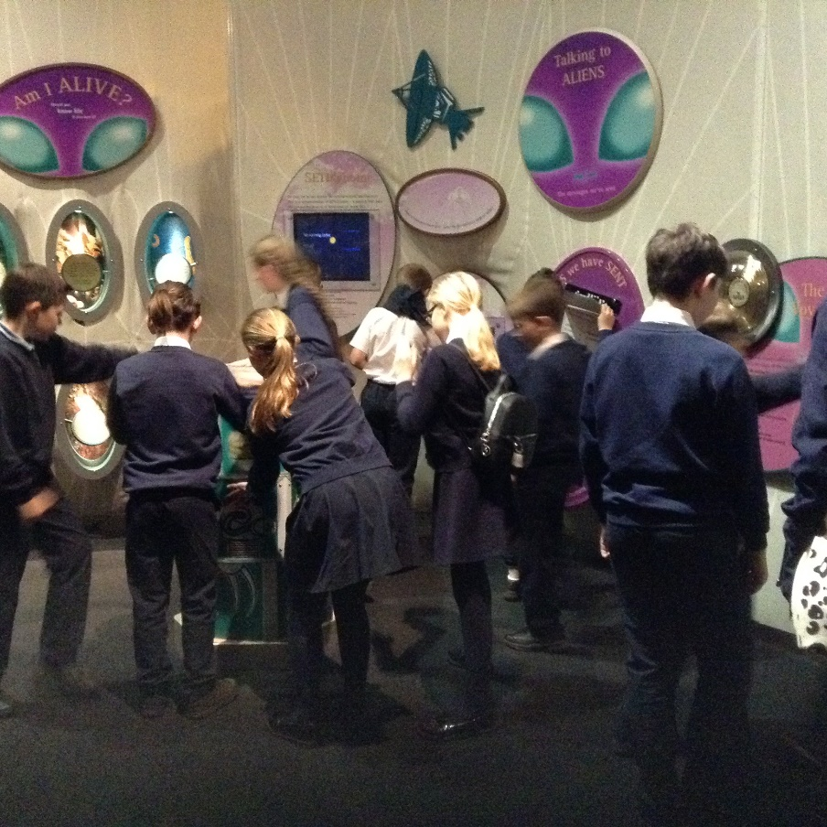

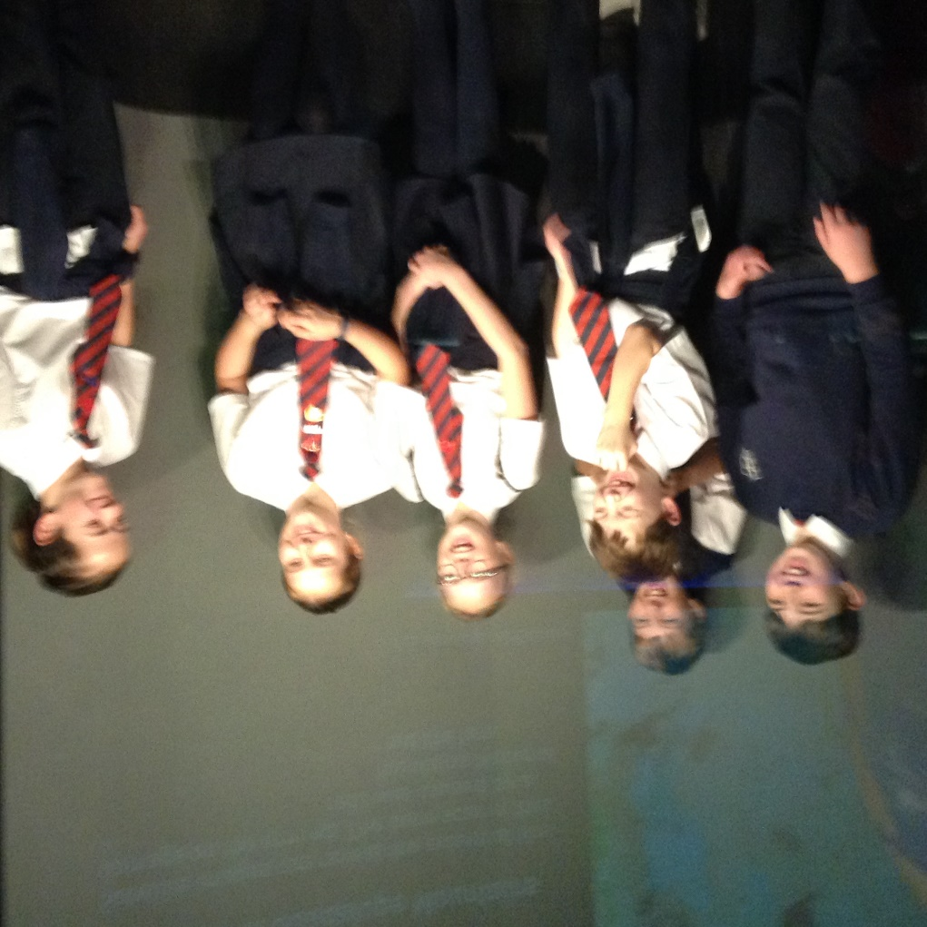
This picture says it all – such enjoyment and camaraderie amongst our Y6 children!
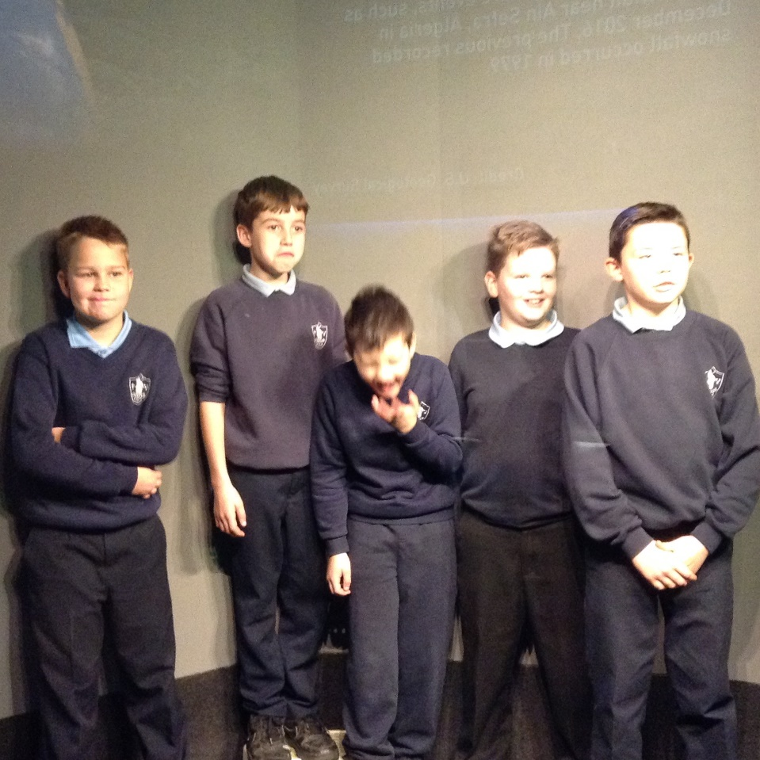
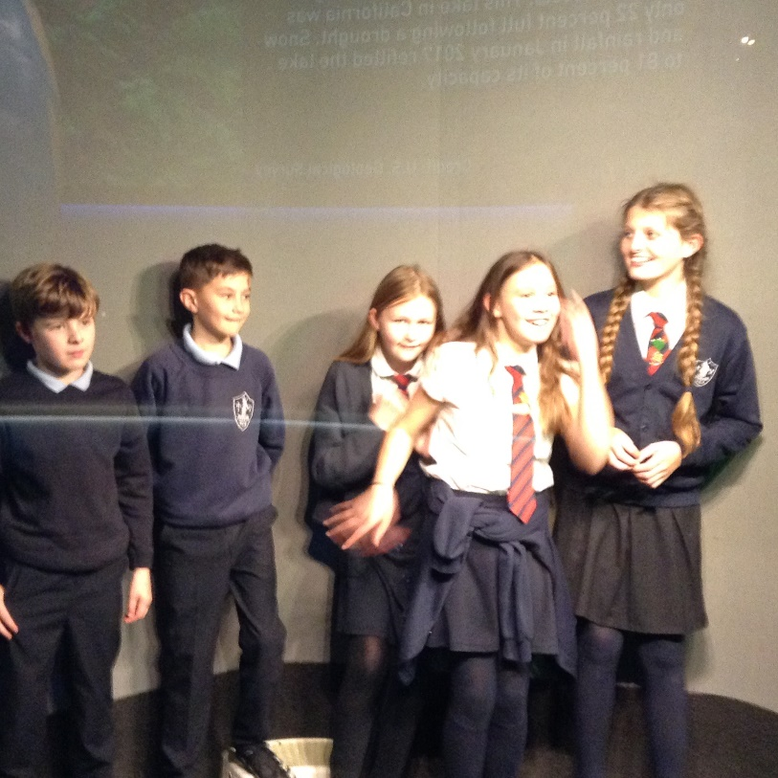

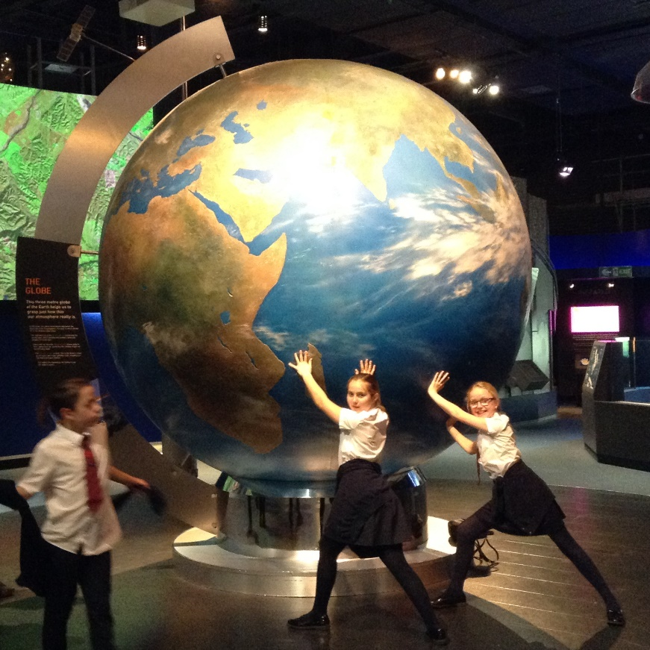
We are incredibly grateful to The Friends of Denver School for funding the coach, parents for contributing to the cost of entry and our generous adult helpers Mrs Mills, Carole, Mrs Adams, Miss Loveridge and Mrs Collins.
Thank you also to the children for their enthusiasm and for being a pleasure to take.

