Father Christmas comes to visit Class 4
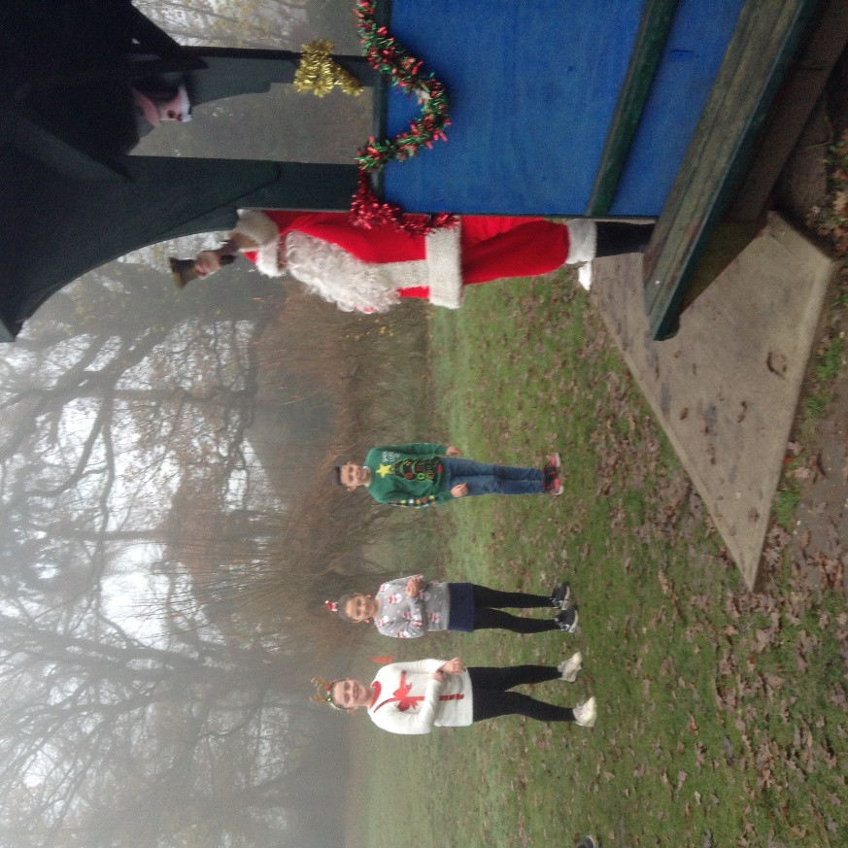
Having arrived by sleigh and announcing that he’d parked it with a farmer friend on Sluice Road (along with the reindeer who were busily refuelling with carrots), Father Christmas came to visit the school to deliver presents.
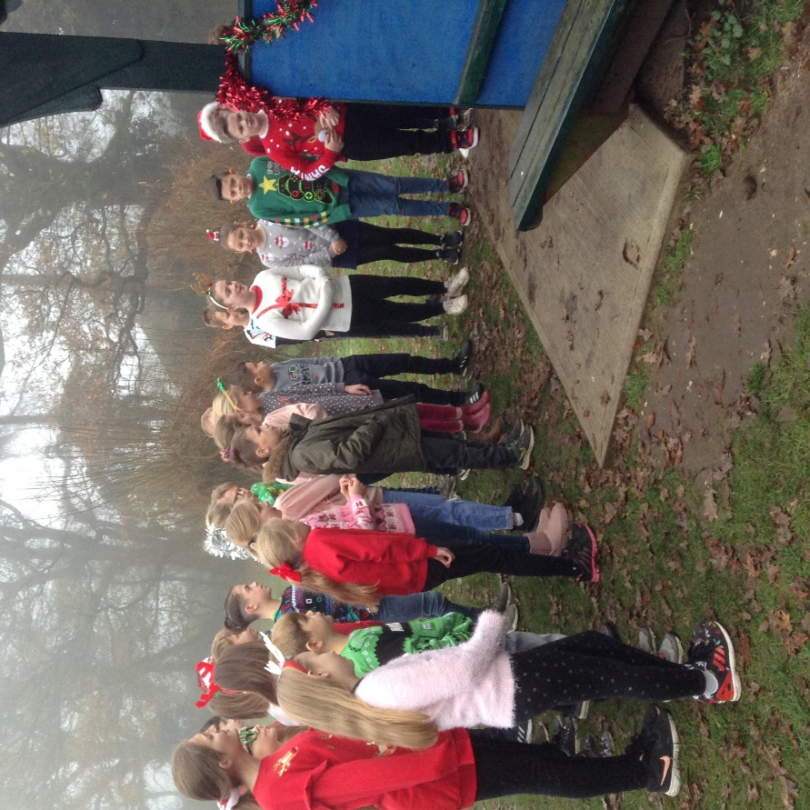

He descended the foggy field loudly announcing his arrival by ringing his bell.

Interesting questions were asked by the children. As always, Father Christmas was asked his age and gave the same reply as in previous years, “As old as my tongue and a little older than my teeth!”
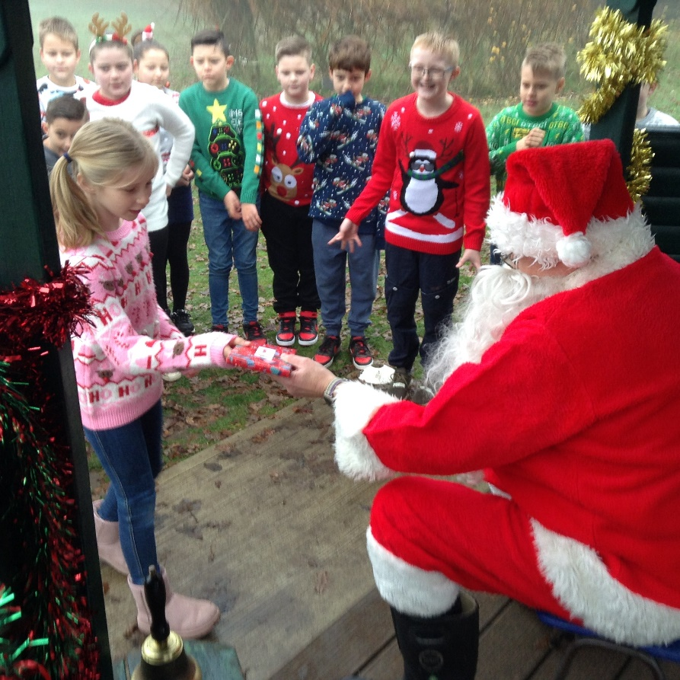

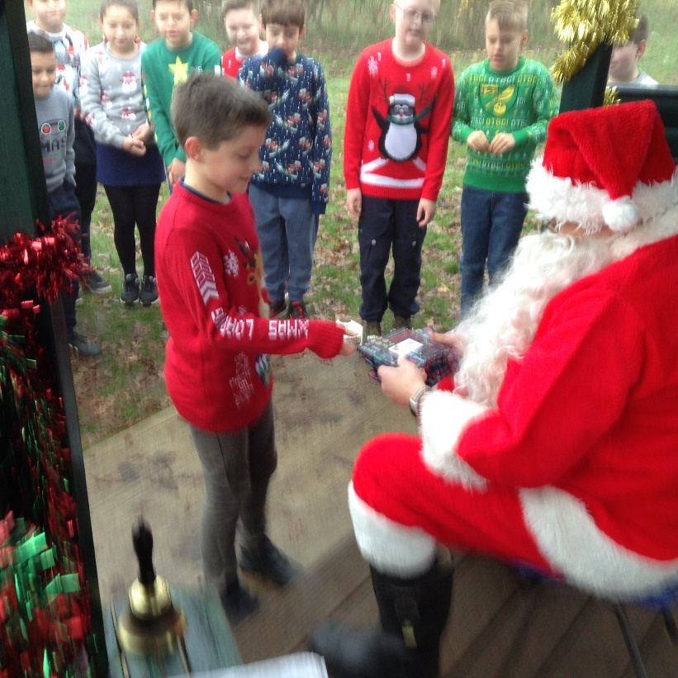
The children entertained him with the song they performed at the carol service. Father Christmas quickly picked up the moves and joined in – he was pleased that it had improved his stats on his Fitbit. Apparently, Mother Christmas has been nagging him about his waistline all year.
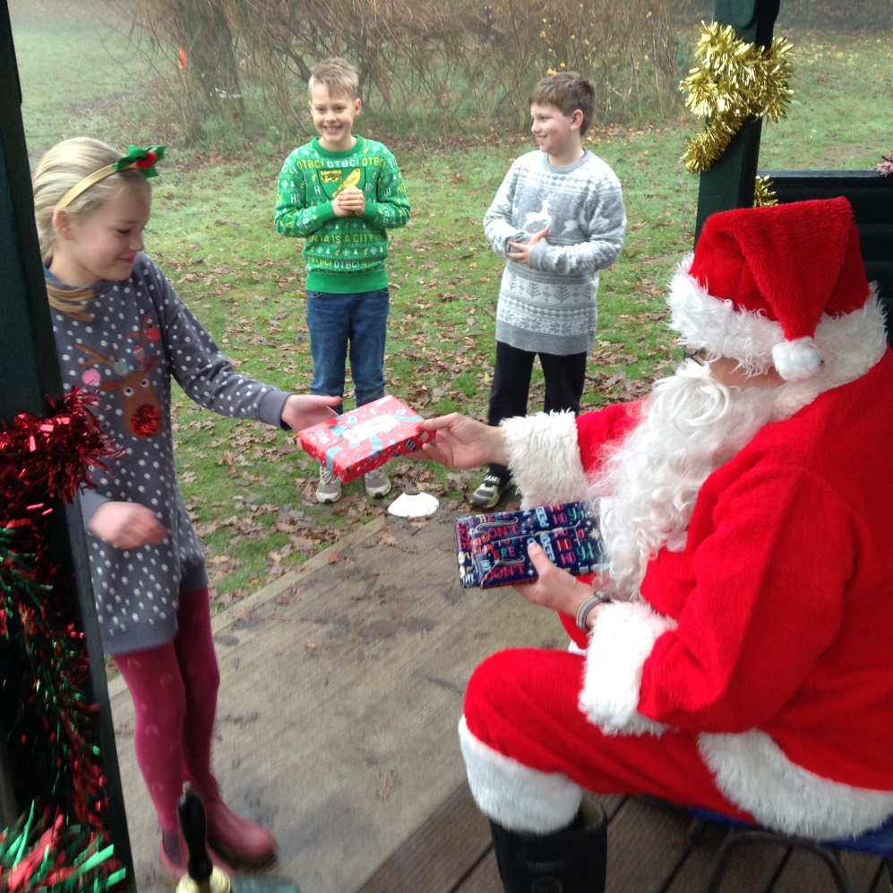

Gifts were then given to the children. They posed with their Christmas jumpers for a photograph which Father Christmas photobombed!
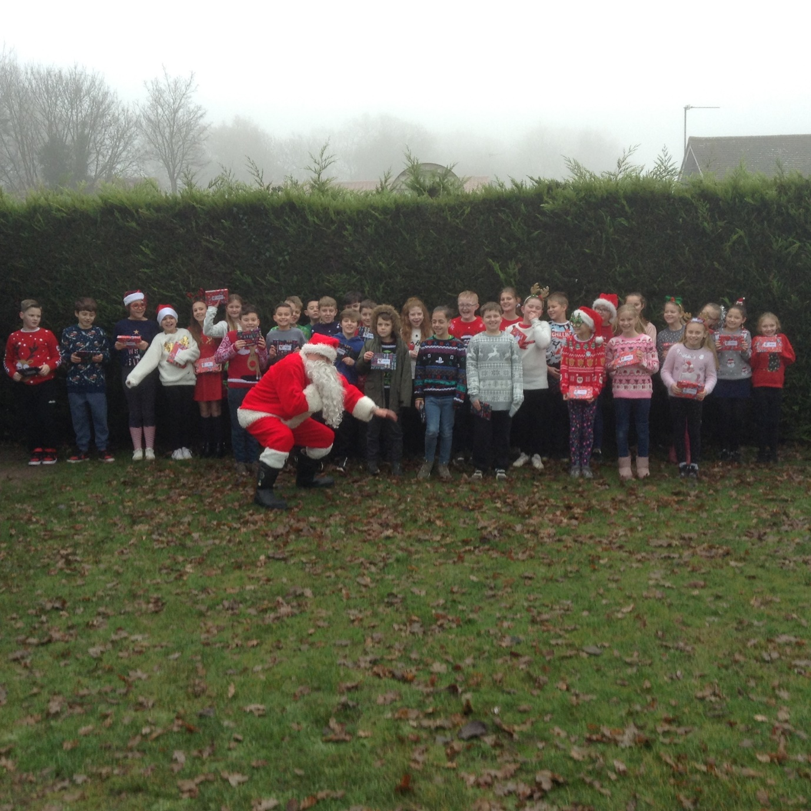

Then off he went again, disappearing into the fog and promising to be back on the night of Christmas Eve….

