Class 4 Christmas party
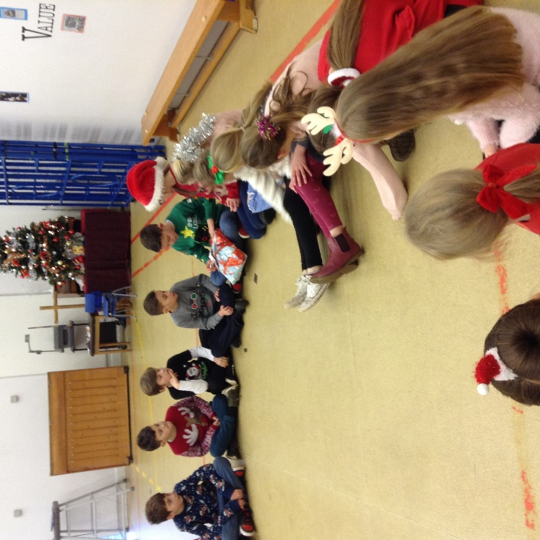

On the last day of term, Class 4 celebrated the coming of Christmas with a party.
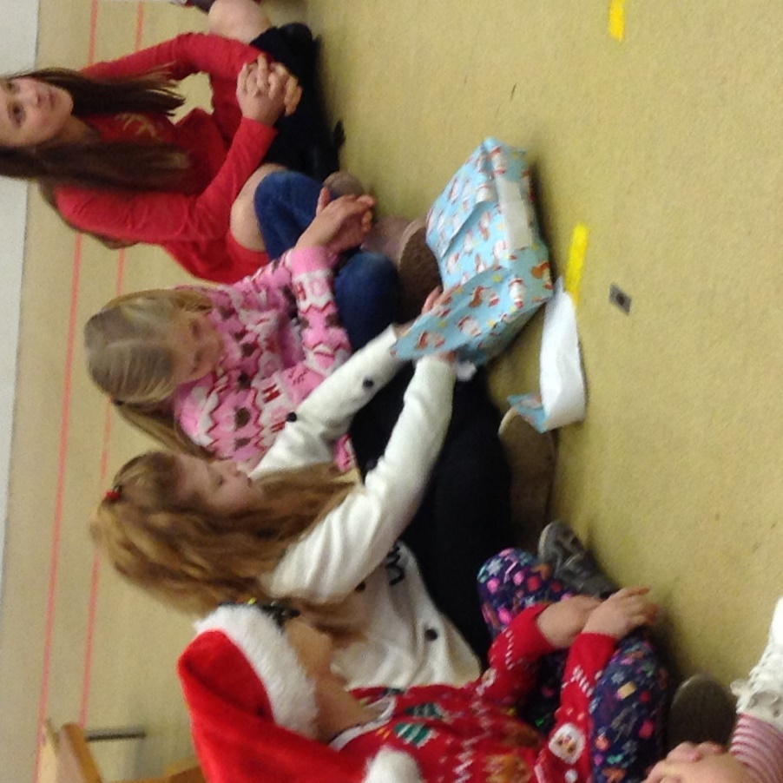

Traditional games such as ‘Pass the Parcel’ were played.

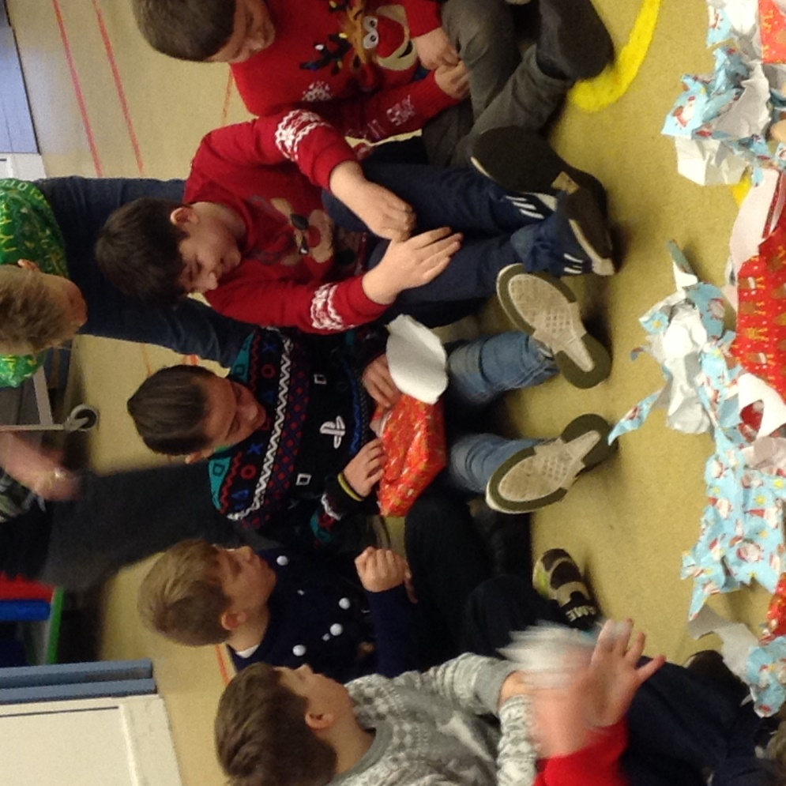
Other games included ‘Corners’, ‘Musical Statues’ and ‘Musical Chairs’.
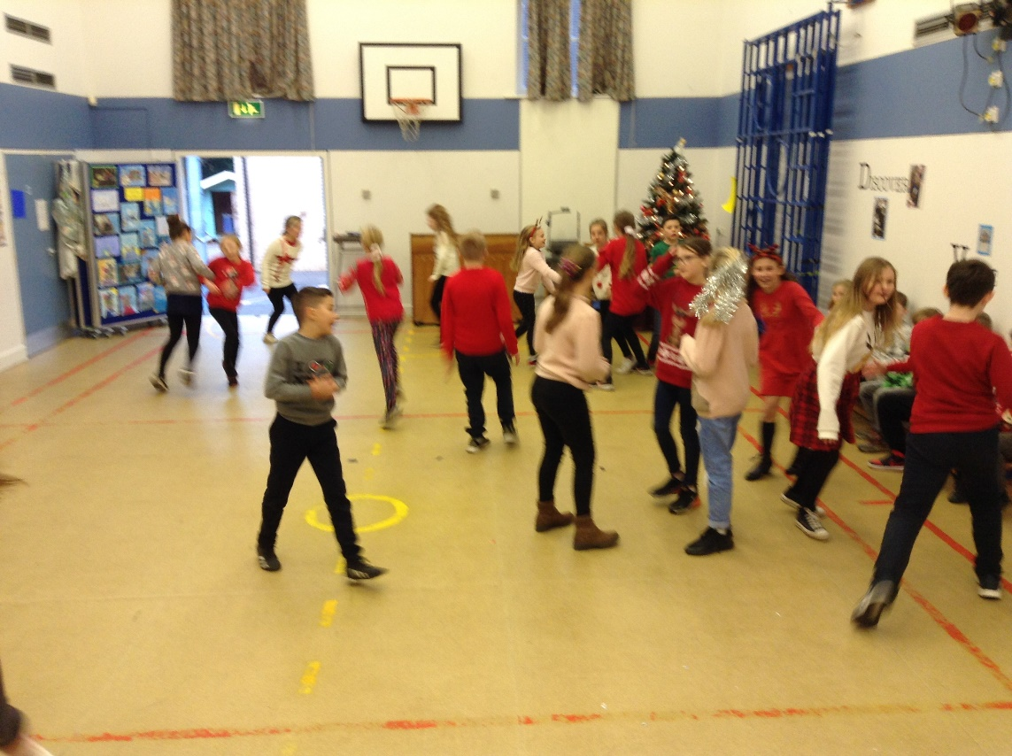

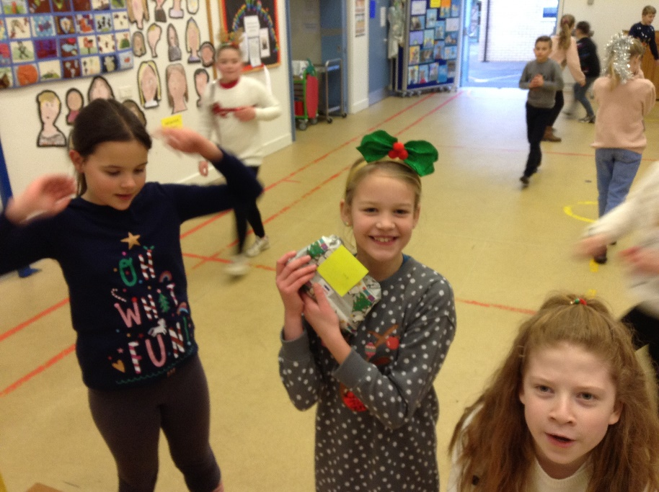

It was a lovely way to round off the term. We are very grateful to the Friends of Denver School for providing the prizes and for taking the time to wrap the sizable parcel so that all 33 of the children were included.
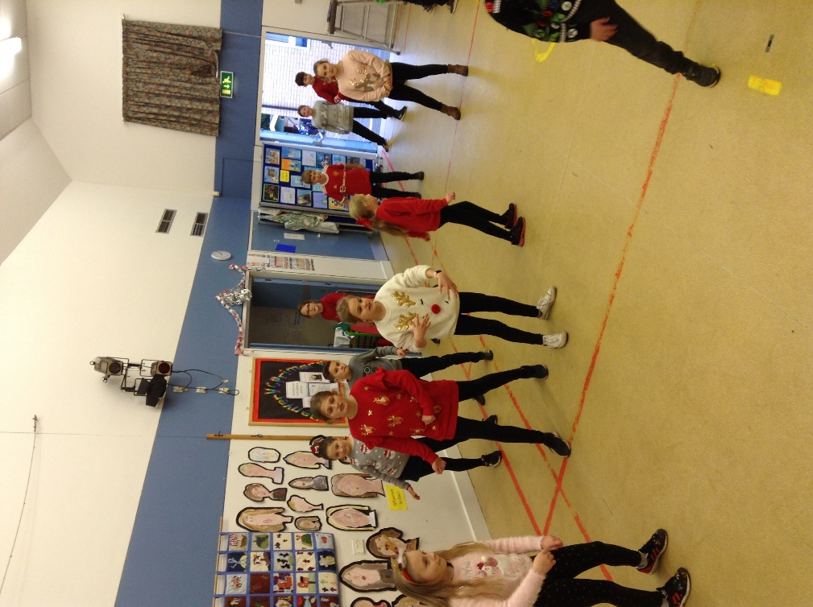

Merry Christmas!


