Children’s Mental Health Week

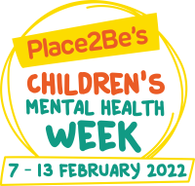

This week is Children’s Mental Health week. To mark the occasion, during our normal wellbeing assembly, we watched the special online assembly organised by Place2Be and starring well-known children’s entertainers.

This year, the theme is ‘Growing Together’. The assembly explores our emotional growth and development. Children were encouraged to imagine they had support balloons and to think about who and what helped fill that balloon. They were then encouraged to think about how they themselves might be in someone else’s support balloon to show care and empathy for others.

The next stage was to think about how goal setting can help us to move forward and out of our comfort zones to achieve new or better things. This was related to setting goals for our emotional growth such as being kind or taking responsibility.

Due to tag rugby, some of our children missed the assembly but it is strongly recommended that they watch it. I am sure they will find it helpful and interesting. This is the link:
https://www.childrensmentalhealthweek.org.uk/news/watch-our-children-s-mental-health-week-2022-assemblies-with-bafta-kids/

This link also provides access to further resources and follow-up activities for children and useful information for parents.

