Year 6 Crucial Crew 2022
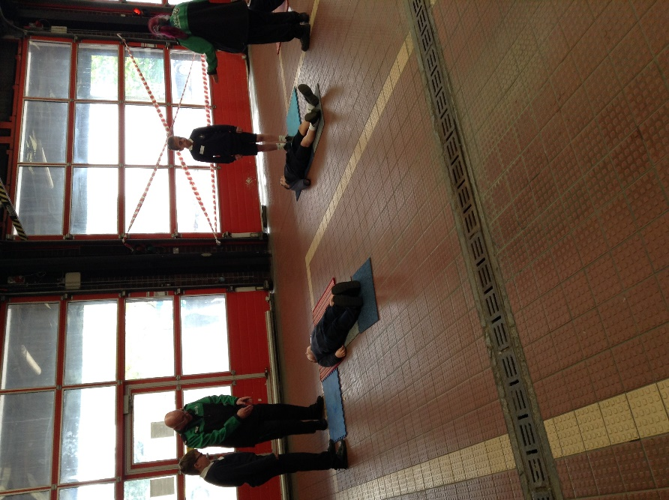
As part of our RSHE and citizenship studies, children in Year 6 visited King’s Lynn Fire Station for its annual Crucial Crew event. This was the first time it had been held face to face since 2019 (the last 2 years were done virtually). Members of organisations such as Norfolk Constabulary, RNLI and St John’s Ambulance led the workshops.
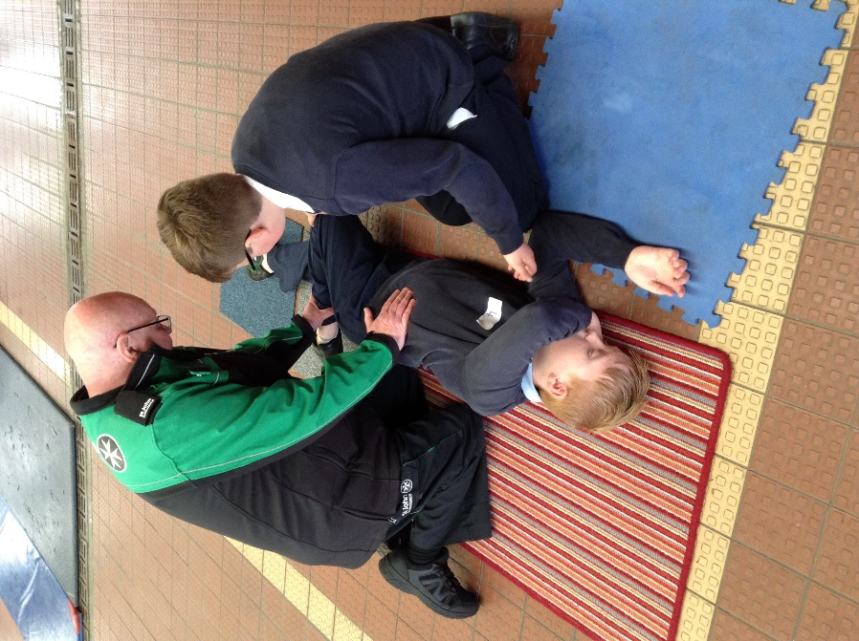
The aims of the event are to equip children with the knowledge and skills to keep themselves safe in a range of situations and how to help someone who needs emergency first aid.
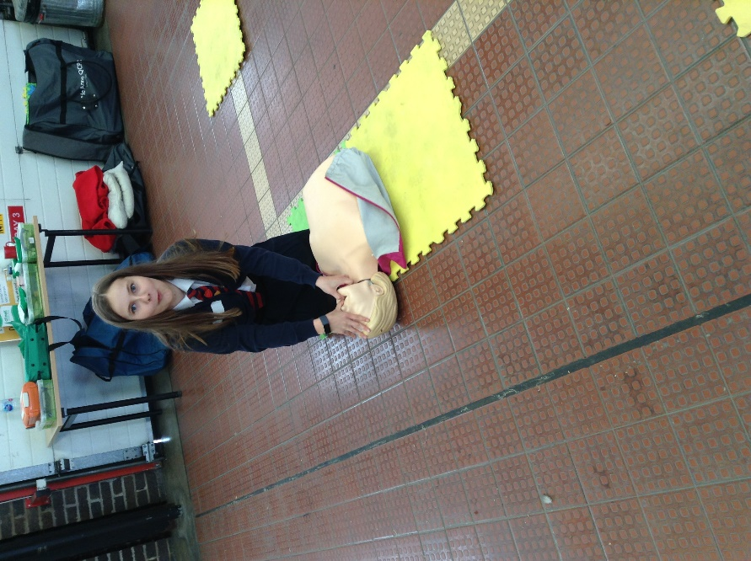
The children worked around 9 different stations, each with a different theme. 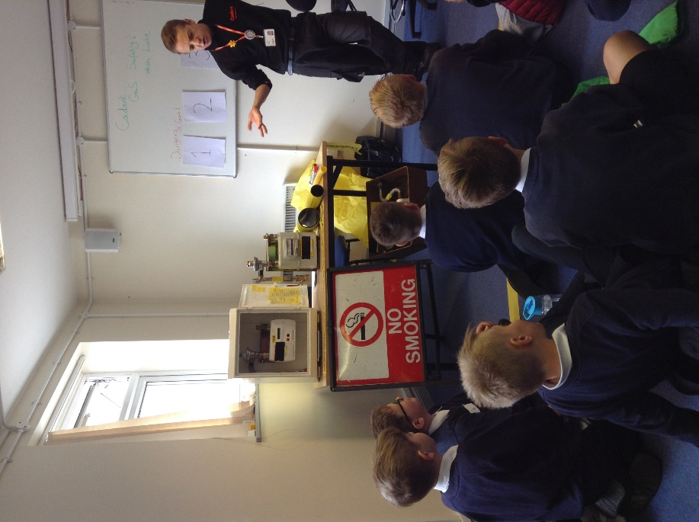
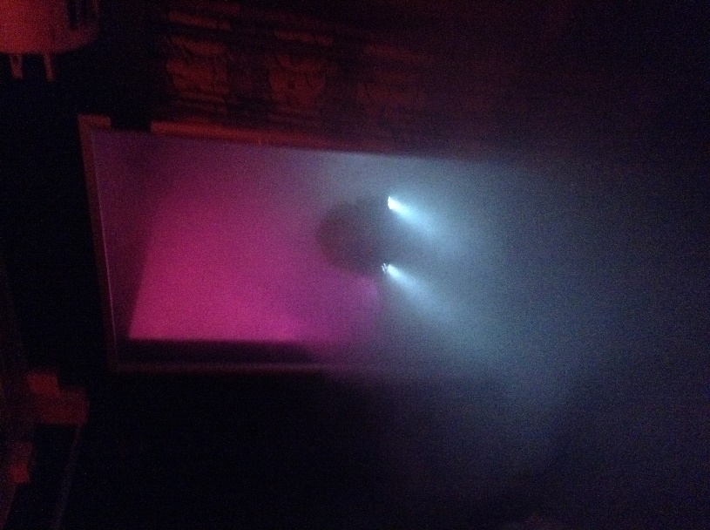
These included how to assess whether a casualty is responsive and how to put people into the recovery position, how to give CPR, road safety, recognising fire hazards, protecting our emotional wellbeing, what to do if you smell a gas leak, staying safe online and managing risks associated with peer pressure with cigarettes, alcohol and drugs.
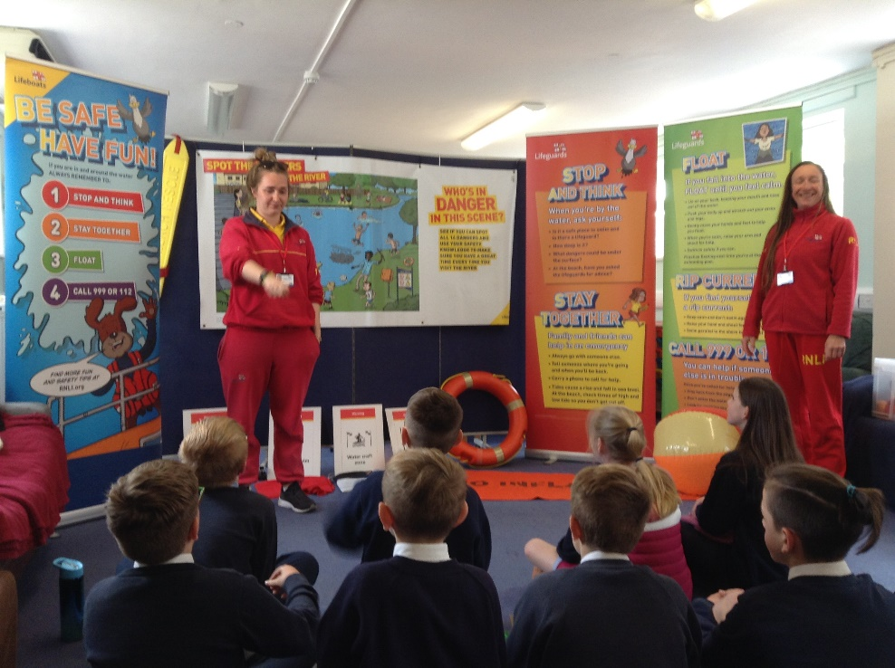

The event was generously supported by King’s Lynn Rotary club volunteers who escorted the groups to each of the stations.

