West Norfolk Beekeeper’s Association visit
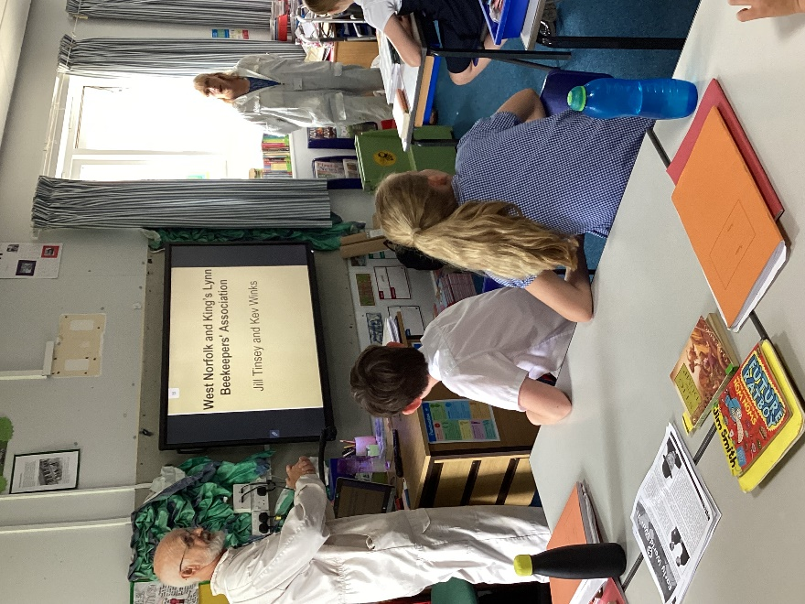
Each of the classes received a visit from the West Norfolk Beekeeper’s Association representatives Jill and Kev on Thursday 23rd June to enrich our science curriculum about life processes and our Eco-Schools status.
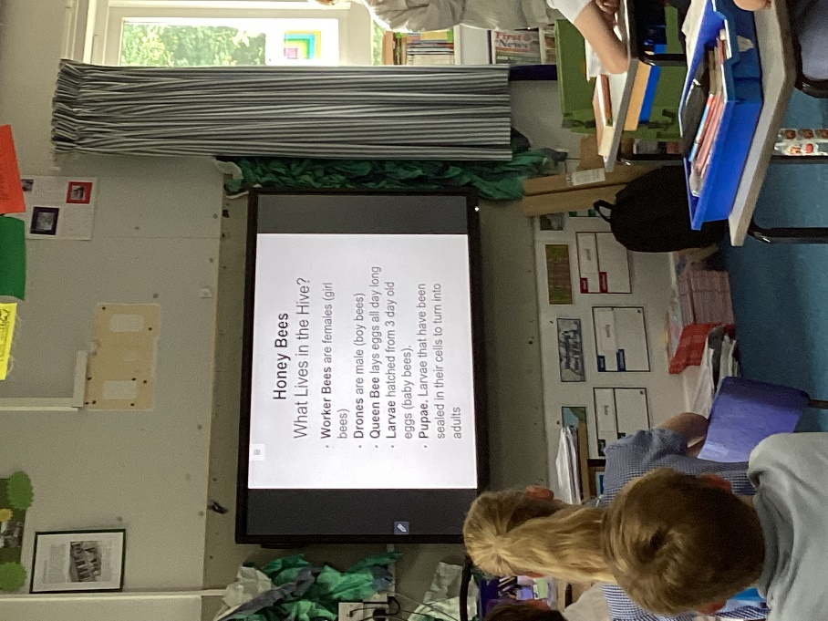
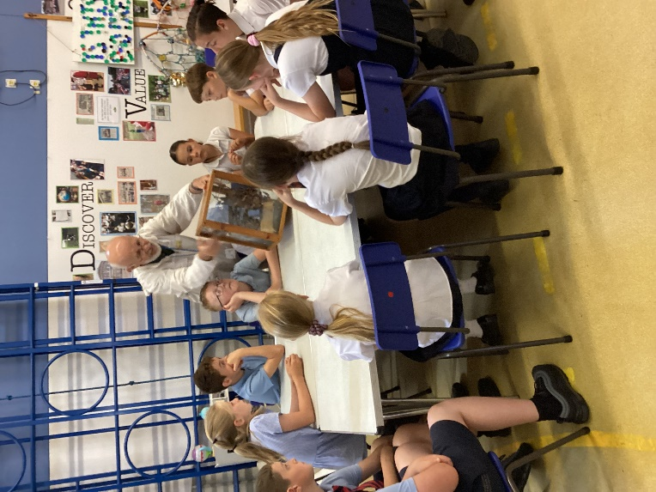

They shared some important information about the different types of bees, hoe they reproduce and how they are helpful to us.

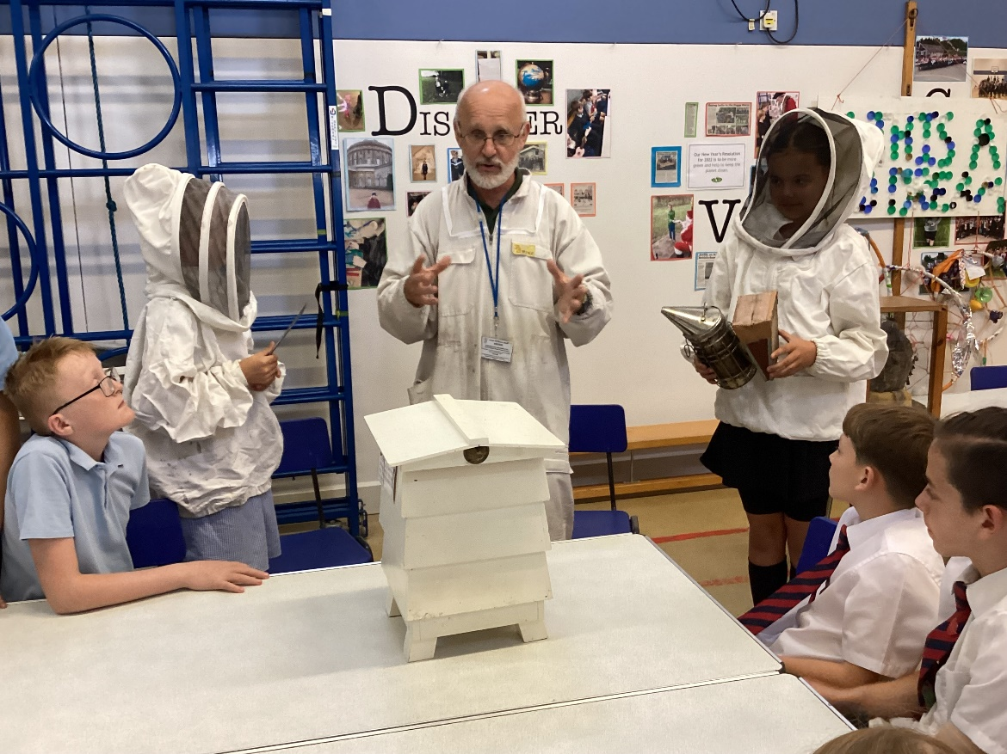

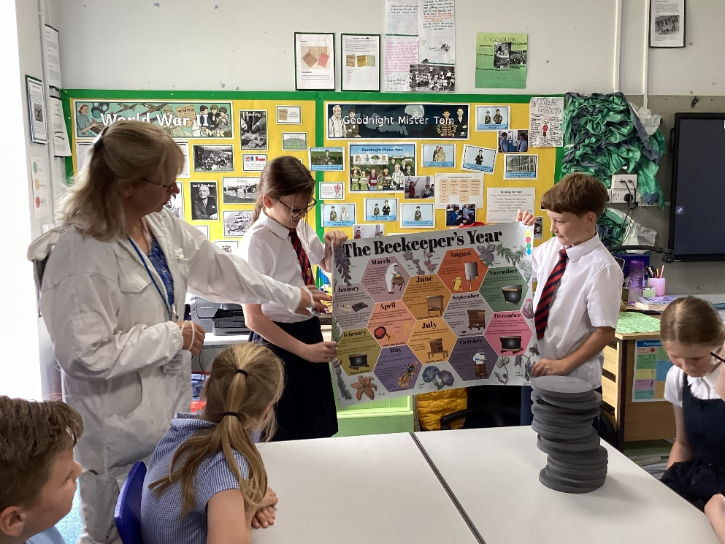
They then set up two workshops. The first involved classifying bees and discussing the work of a bee keeper. The other explained how bees make honey and what goes on inside a hive. The children were able to observe bees in action and spotted the Queen bee.
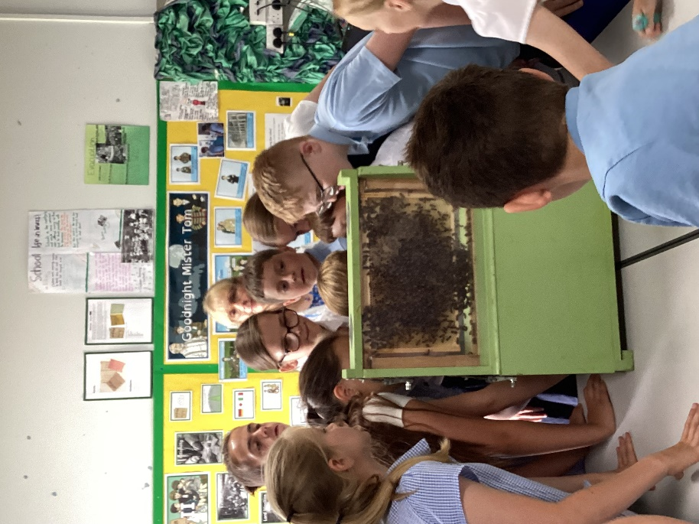

It was really interesting to learn about these wonderful little creatures that do so much important work.

