Letting our lights shine
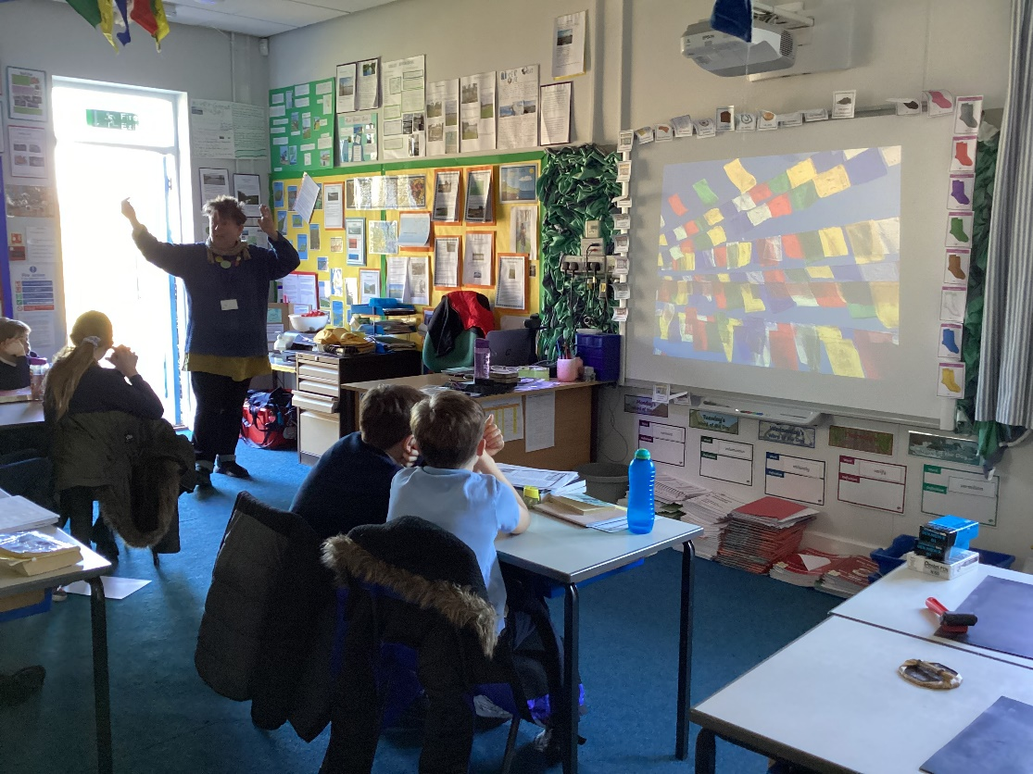
On Thursday 10th March we were very lucky to be joined by Carole Reich, one of our school governors, to make prayer flags for the school.
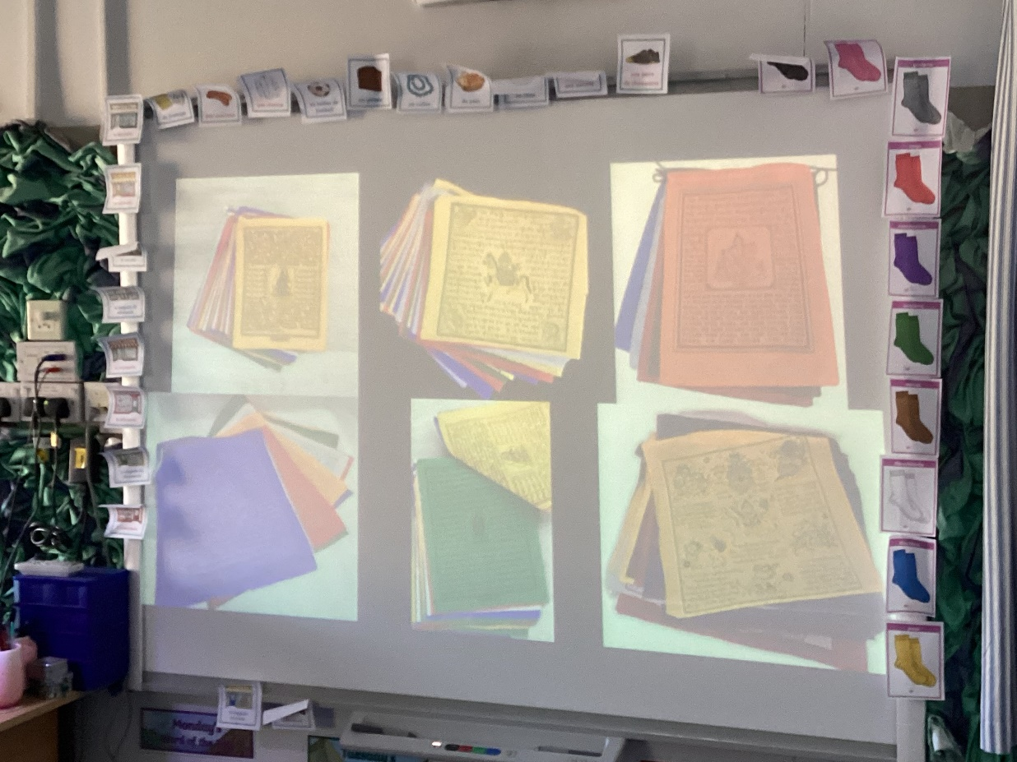

She taught the children about the origin of prayer flags and the use of symbolism.
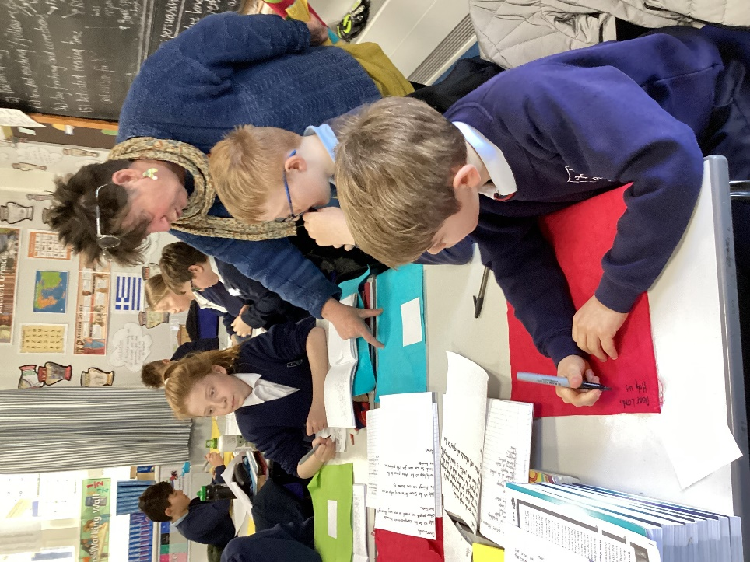

The children wrote some very heartfelt prayers about current world events.
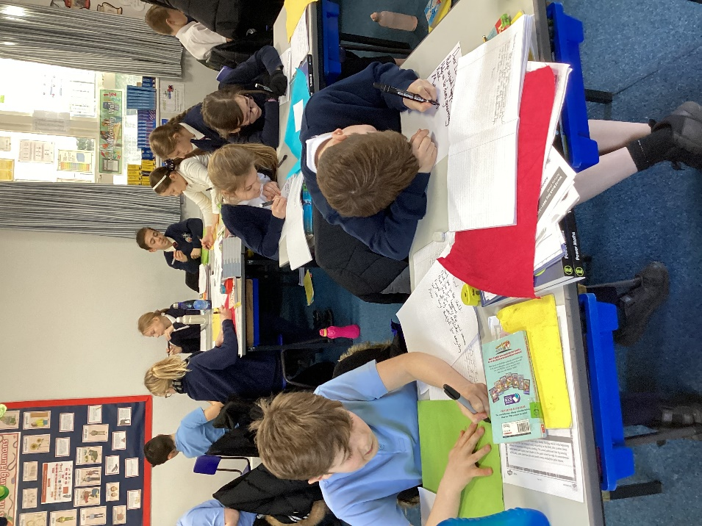
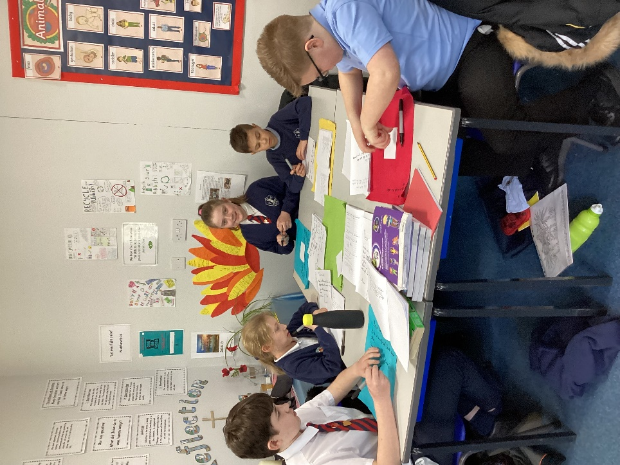
Many of the children linked their prayers to the school vision of letting our lights shine and to Bishop Stephen’s Lent challenge of being a ‘Brave Believer’.
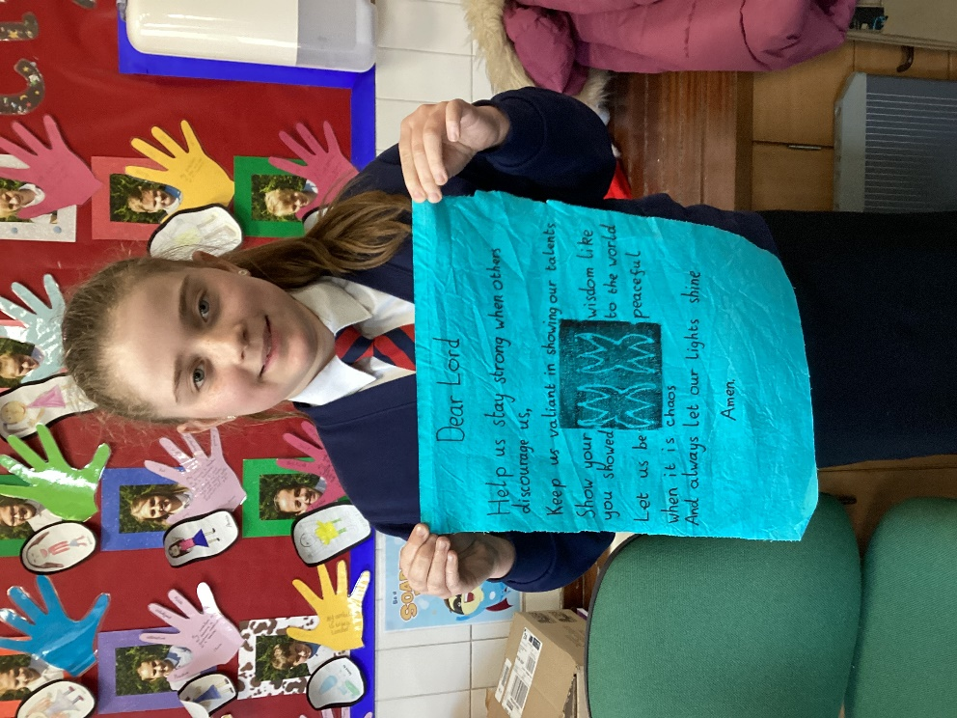
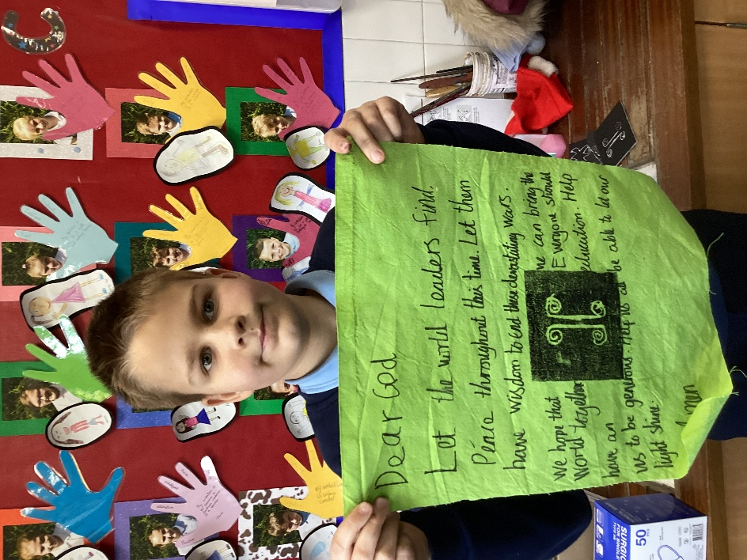
The children invented their own symbols with a particular meaning to them. Lots of the examples linked to the Christian values we have been studying such as compassion and hope.
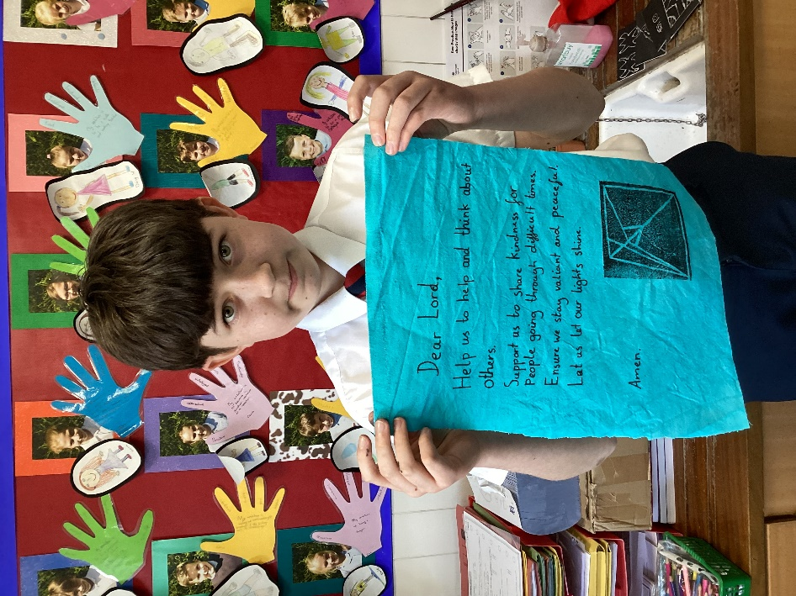

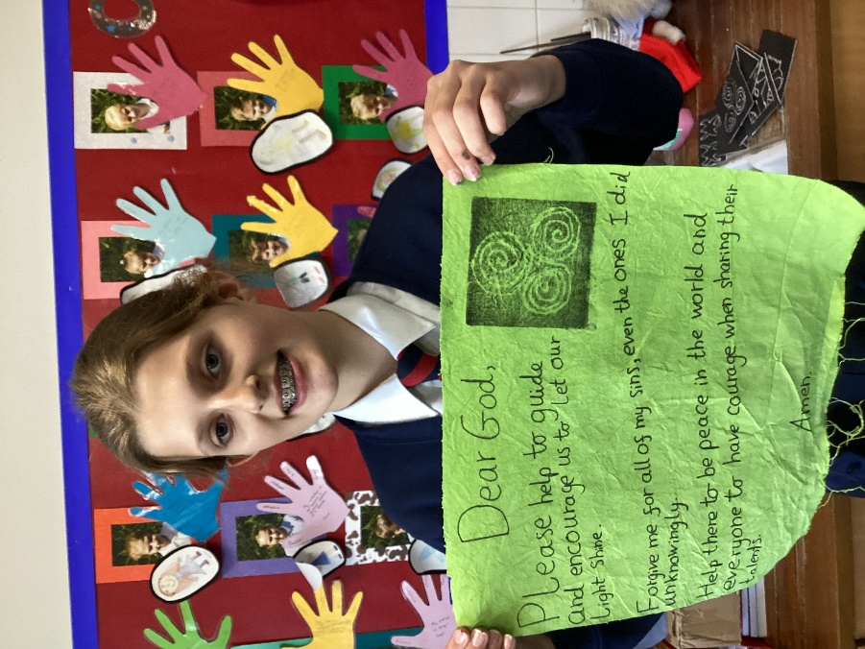
Carole will be returning soon for those who didn’t quite get time to finish their flags. These will then be joined together to make a very vibrant display around the school reflection area and entrance.
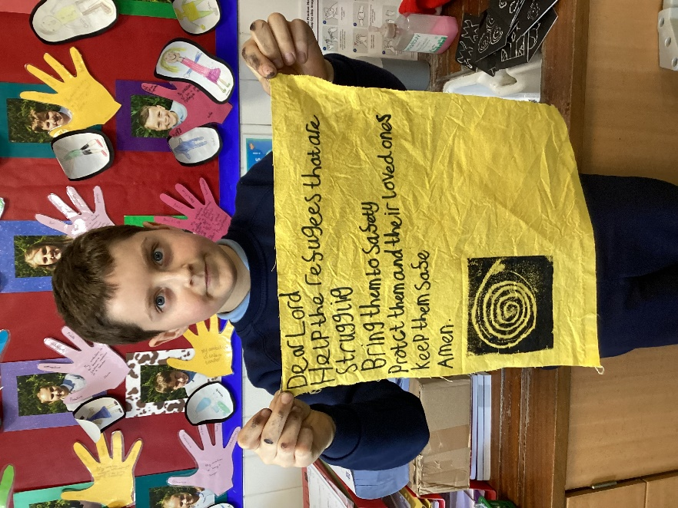

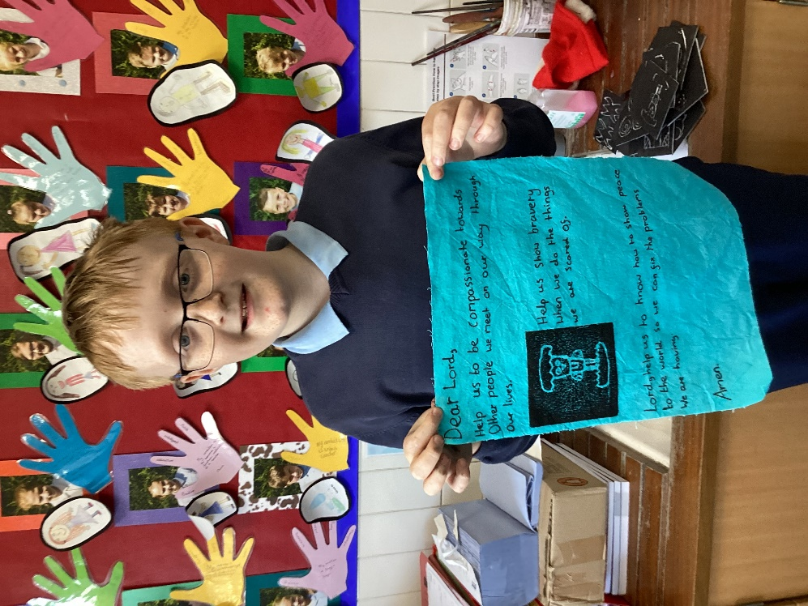
It was pleasing to see the children showing compassion in their thoughts and ideas.
