Cards from our French Penpals in Paris
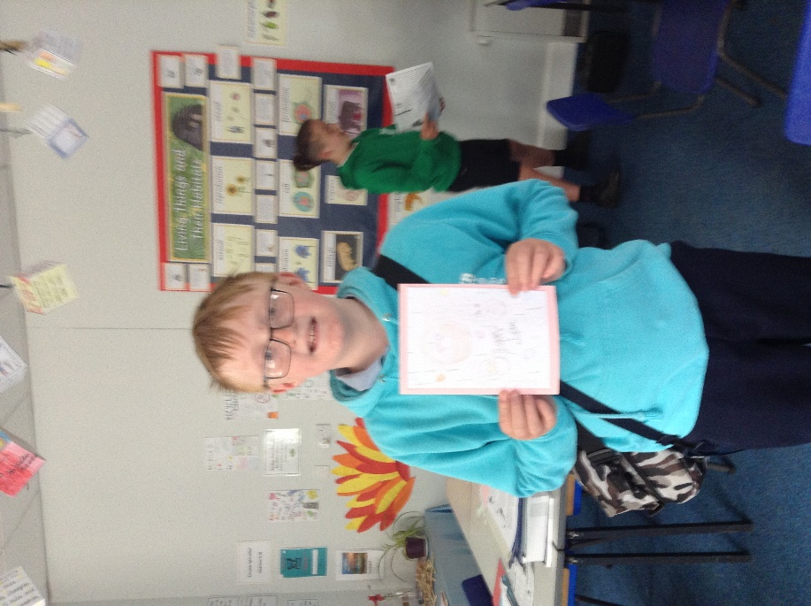
In Class 4 we were delighted to receive some replies to our Easter cards from our French counterparts.
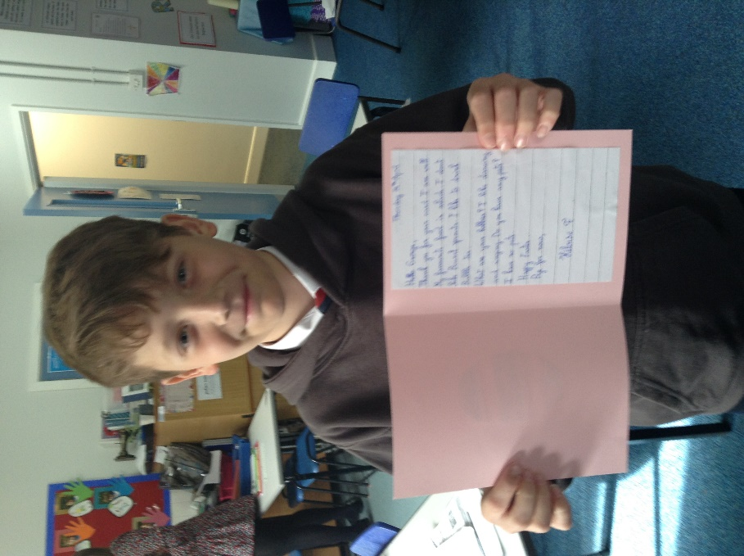
The children from Saint Victor Primary in Paris responded in English to the questions and information that we had written to them in French.
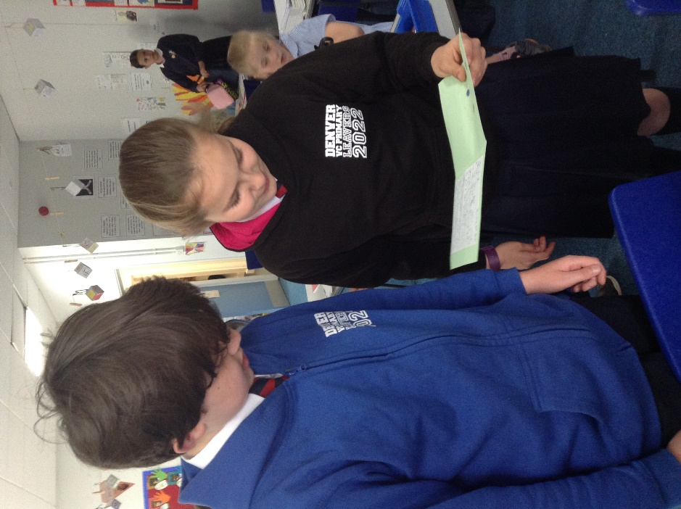
We shall be working on writing our replies in our next French lesson.
