Instructional writing.

In their literacy, Class 2 have been learning how to write instructions. They learnt all the features and the importance of a chronological order.
They had great fun giving instructions to Lily to help her make a jam sandwich. There was nearly jam everywhere as they forgot to tell her to use the knife to get the jam and put it on the bread.
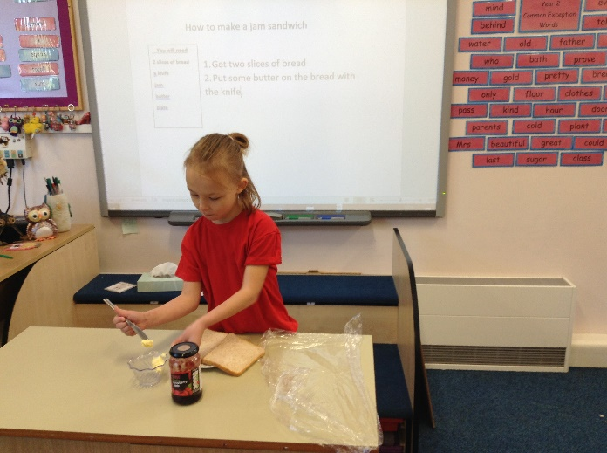
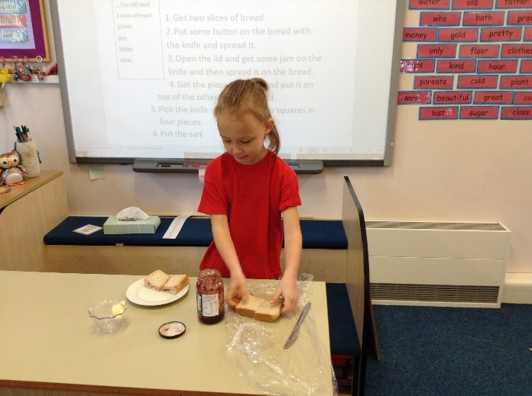

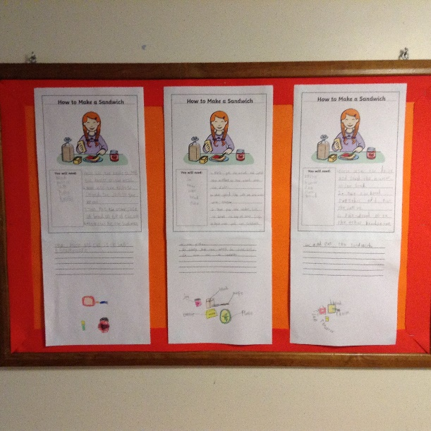
They each wrote their own instructions on
How to Make a Jam Sandwich’.
Some of the work is on display and I
thought you might like to see it as you
are unable to come into school during the
present circumstances.

