Multi Skills training with Norwich City Community Sports Foundation
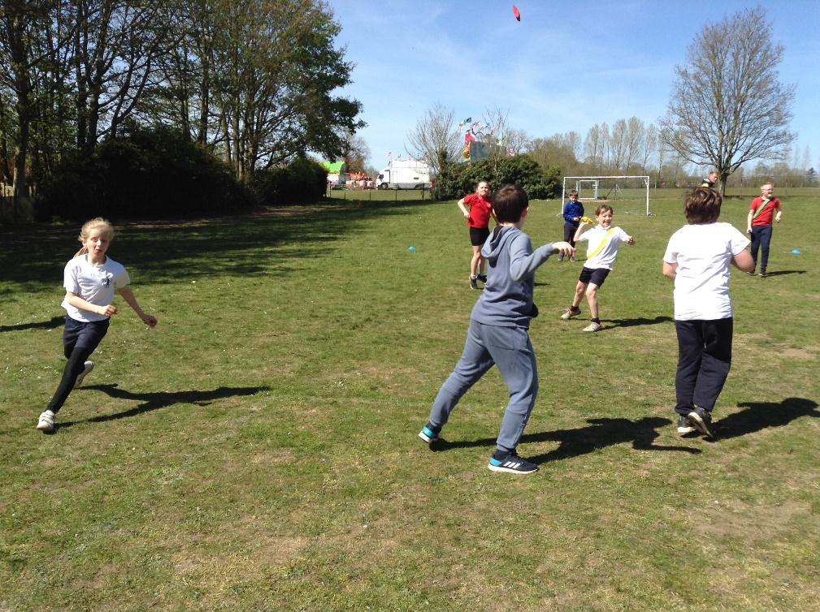
On Friday 23rd April, Classes 3 and 4 each had an hour of multi-skills coaching with Tom from NCCSF.
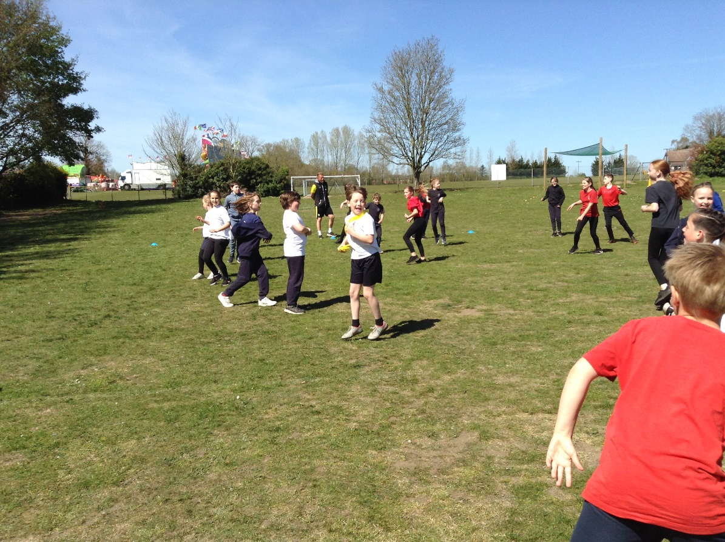

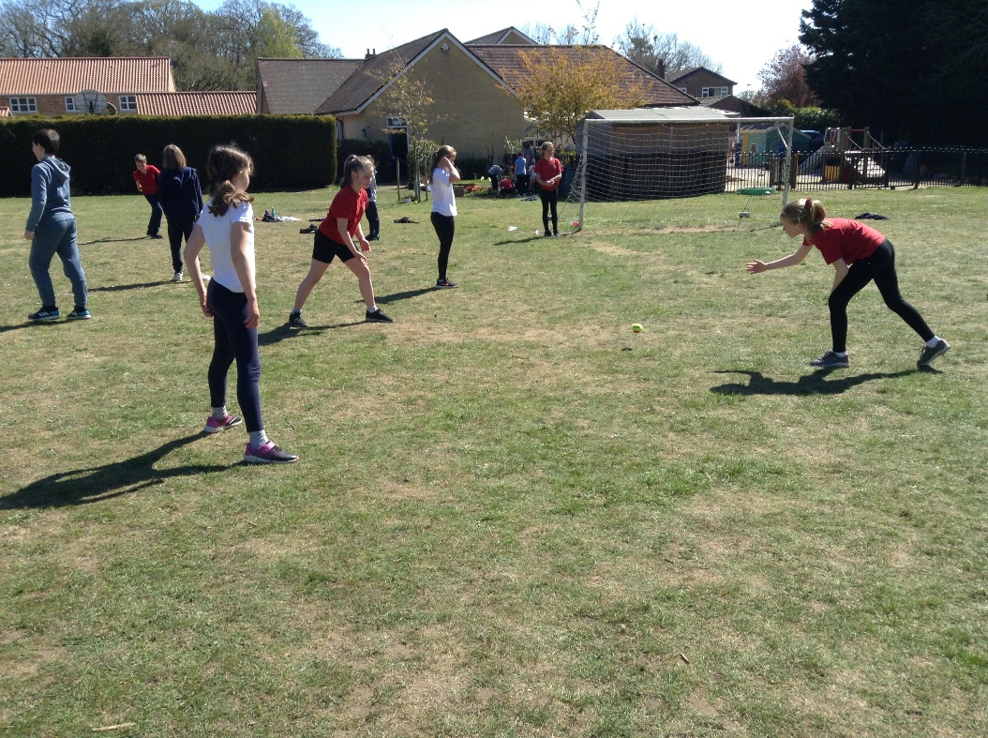
This week explored fielding skills related to cricket. Each week for the rest of this half term will be used to develop key skills with the focus next week on bowling techniques. Classes 1 and 2 will have this opportunity in the second half of the summer term.
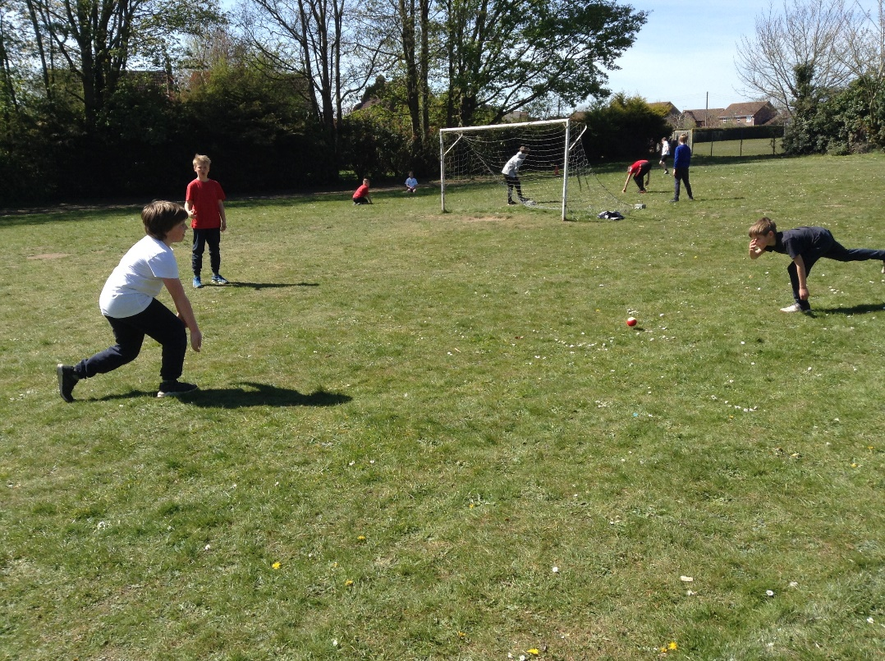

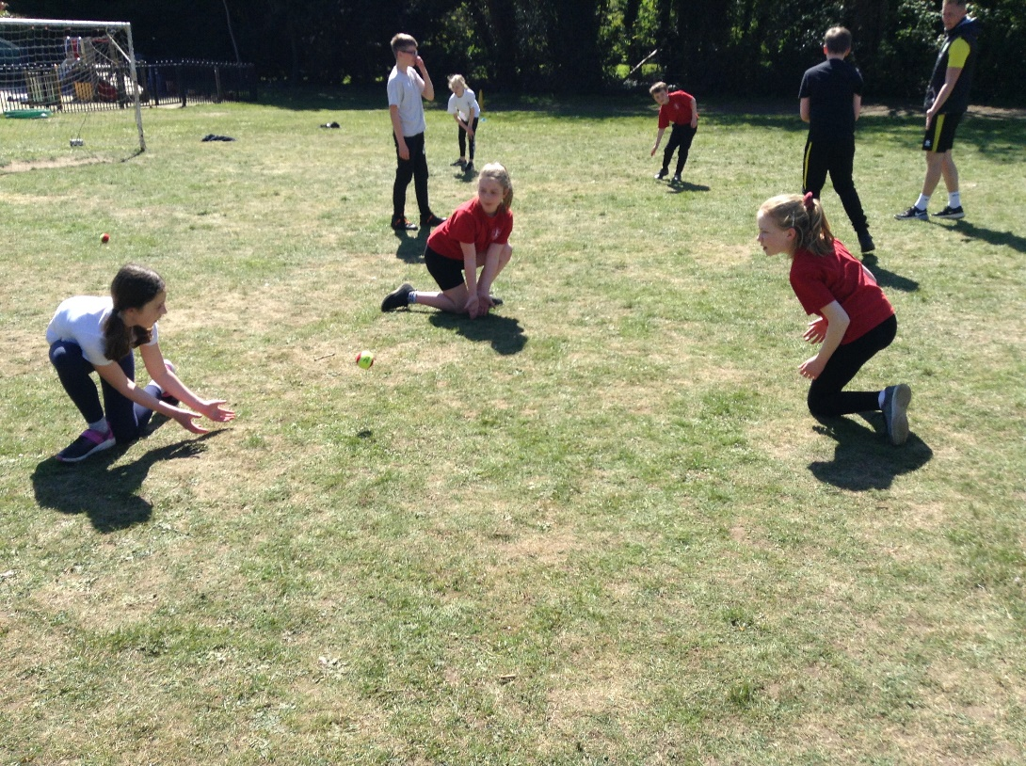
At the end of each session a game is played using the skills developed in the session.
