Cultural history of the Fens
As part of their history learning, the children in Class 2 learn about the Fenland culture. A visit had been planned for the spring term to go to Prickwillow Drainage Museum and the Ely Museum.
Unfortunately we were unable to make the journey this year. The museum staff were extremely helpful in their quest to enable the children to continue their learning under the very difficult circumstances we found ourselves.
They sent many resources for the children to learn at home and when the Year 1 pupils returned to school at the end of the year, Mr Lawrence taught them one of the songs about Fenland.
The Prickwillow Museum also organised a competition for the schools. The children had to draw one of the engines from the website. All the pupils who were in school at the time sent off an entry. The first prize was awarded to Rosie, second prize went to Jack and Eric secured third place. All the pupils who took part received a pen.
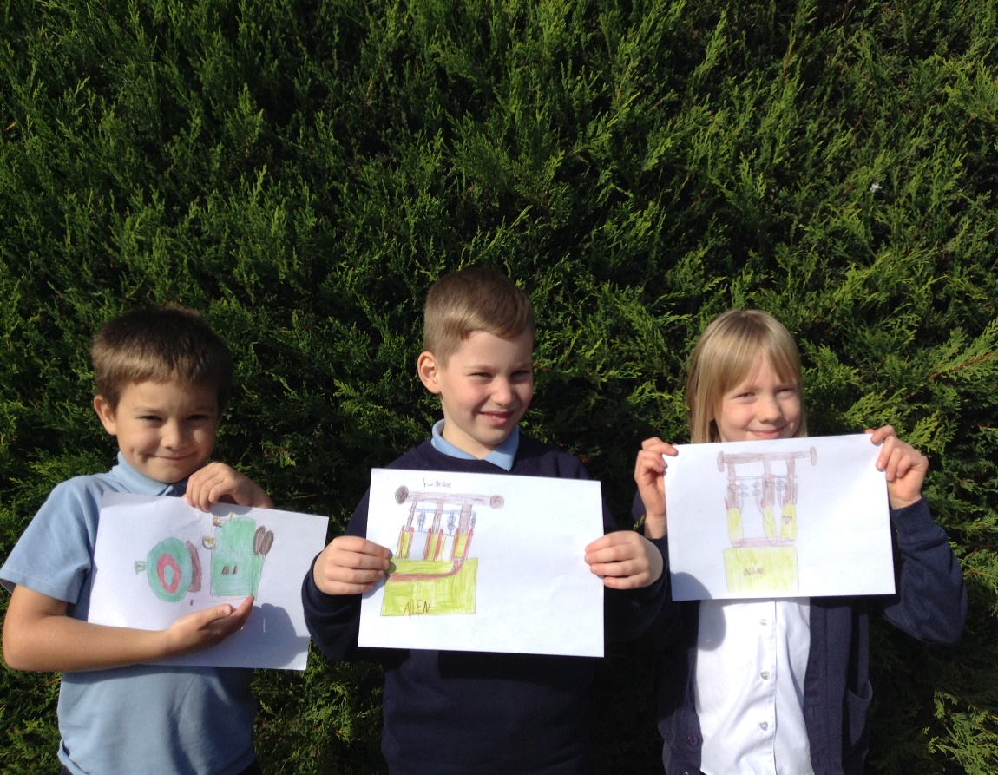
Prizes will be awarded to the winners when the museum opens again in the spring and all the entries will be on display. I am sure the children would love to go and see them and also learn a little more about the Fens.

