French Pen Pals

In our French lessons, we have been corresponding with children from Paris. They have recently received our letters and have sent the following note and pictures of them enjoying reading the letters we sent to them.

Dear Class 4
Thank you for your letters, we were delighted to receive them!
We’re working on our replies 😊📮
À bientôt!
La classe de CE1, Saint Victor

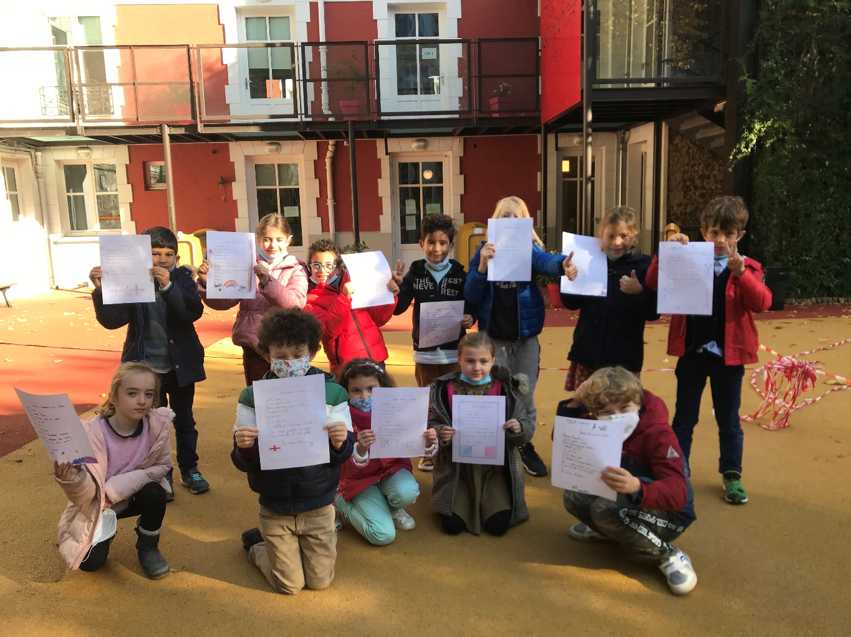

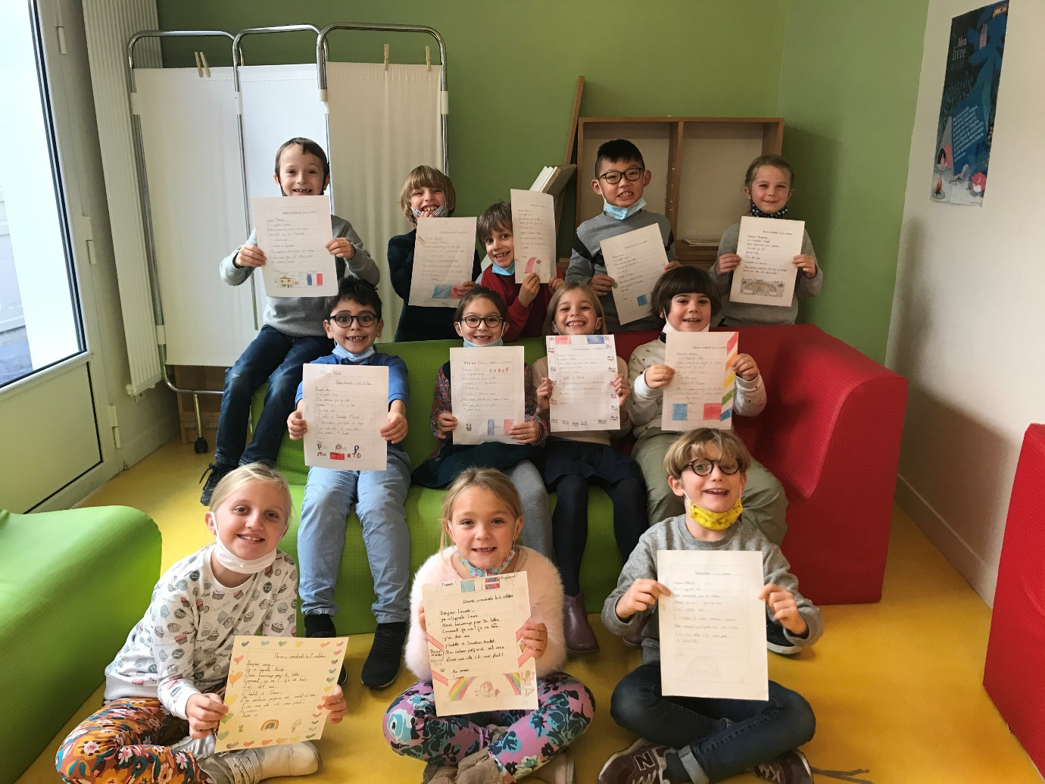

05/11/20

